

Lab Manual
Subject: Data Mining

By
Tehreem Fatima 2023-BS-AI-026
Semester 6th
Course Code DS-303
Supervised by Sir Arham
The University of Faisalabad
Bachelors of Science in Artificial Intelligence
DEPARTMENT OF COMPUTER SCIENCE

Contents
Lab 1: Introduction to Data Mining 3
Lab 2: Introduction to KNIME (Iris Species Analysis) 6
Lab 3: CRISP-DM process (Orange Data Mining) 10
Lab 4: Data Cleaning 14
Lab 5: Data Preprocessing 18
Lab 6: Market Basket Analysis 26
Lab 7: Apriori Algorithm 30
Lab 8: FP-Growth 33
Lab 9: Python Basics 37
Lab 10: Decision tree 44
Lab 11: Naïve Bayes 50
Lab 12: Naïve Bayes 54
Lab 13: Clustering 58
Lab 14: Outlier Detection 63
Lab 15: Scraping & Sentiment Analysis 69
Lab 16: Final Capstone 73

Lab 1: Introduction to Data Mining
I. Introduction to Data Mining
Data Mining is the process of discovering hidden patterns, correlations, and useful information from large sets of data. It is often called Knowledge Discovery in Databases (KDD). Instead of manually looking at thousands of rows of data, we use software to "mine" the data for trends that help us make better decisions.

The 4 Core Tasks of Data Mining:
- Classification: Assigning items into categories (e.g., "Is this flower a Setosa or a Virginica?").
- Clustering: Grouping similar items together without knowing the categories beforehand.
- Association: Finding rules that link items (e.g., "People who buy milk also buy bread").
- Regression: Predicting a specific number (e.g., predicting the price of a house).
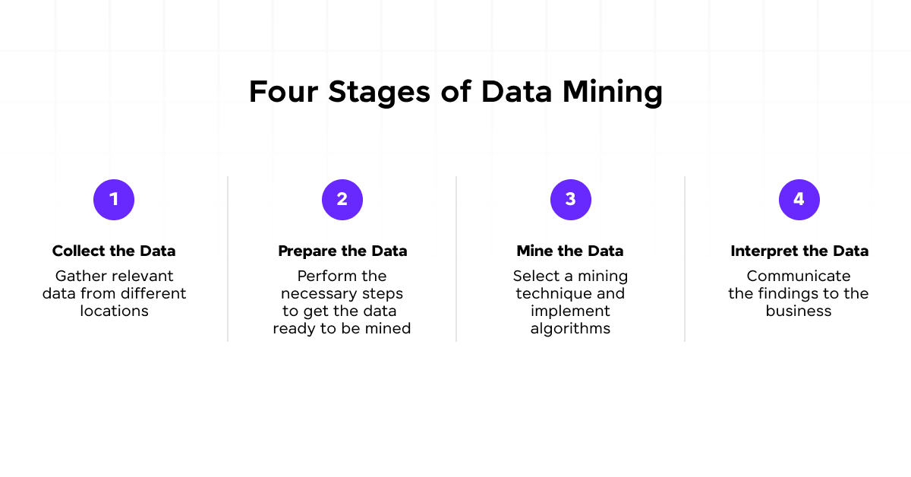
II. Software Introduction (KNIME)
For this lab, we use KNIME (Konstanz Information Miner). It is an open-source data analytics and reporting platform.
Why use KNIME?
- No-Code Interface: It uses a "drag-and-drop" system where you connect blocks (nodes) instead of writing Python or Java code.
- Visual Workflows: You can see the "path" your data takes from the raw file to the final chart.
- Status Indicators (The Traffic Light):
  - Red: The node has an error or is missing settings.
  - Yellow: The node is configured and ready to run.
  - Green: The node has successfully processed the data.
III. Overview of the Dataset (The Iris Dataset)
The Iris Dataset is the most famous dataset in the world of Data Mining and Machine Learning. It was introduced by Ronald Fisher in 1936.
Dataset Details:
- Type: Multiclass Classification.
- Instances: 150 rows (50 samples for each of the 3 species).
- Attributes (Features):
  - Sepal Length (cm)
  - Sepal Width (cm)
  - Petal Length (cm)
  - Petal Width (cm)
- Target (Class): Species (Iris-setosa, Iris-versicolor, Iris-virginica).
Why do we use it?
It is a "clean" dataset, meaning there are no missing values. It is perfect for beginners to learn how to separate different groups based on physical measurements.
IV. Practical Objectives for Lab 2
- To get familiar with the KNIME Workspace and node connectivity.
- To perform Data Ingestion by reading a CSV file.
- To create Visualizations (Bar Charts and Scatter Plots) to understand data distribution.
- To implement a Decision Tree Learner to find the rules that define each flower species.

Lab 2: Introduction to KNIME (Iris Species Analysis)
I. Real-World Problem
A group of biologists has a large collection of physical records for different flower species. Right now, they have to manually look at measurements like petal length and width to figure out which species a flower belongs to. This takes a lot of time and lead to mistakes. We need to create a digital system in KNIME that can look at these physical measurements and automatically group the flowers into their correct species.
II. Dataset Overview
For this lab, I am using the Iris Flower Dataset, which was originally collected by Edgar Anderson.
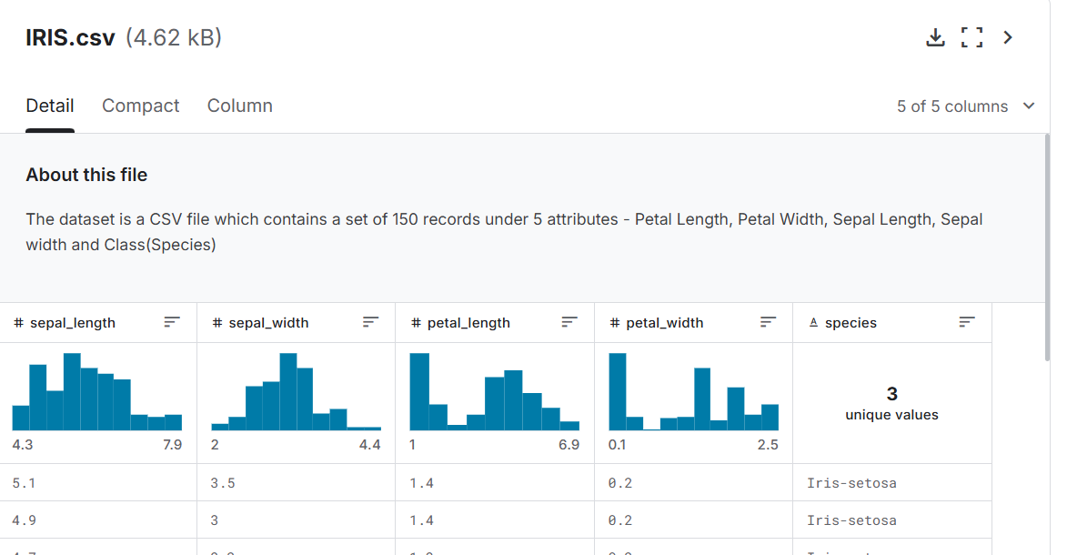
- Source: A .csv file with 150 total records.
- Content: It includes 50 samples for each of the three species: Iris Setosa, Iris Virginica, and Iris Versicolor.
- Attributes: Sepal Length and Sepal Width (in cm)
  - Petal Length and Petal Width (in cm)
  - Class/Species (The target label)
III. Software Environment
- KNIME Analytics Platform: This is a professional tool for data mining that is very easy to use because it is visual.
- Visual Workflow: Instead of writing code, I use "Nodes" (blocks that do specific tasks) and connect them with lines to build a data pipeline.
IV. Practical Objectives
In this lab, I want to achieve the following:
- Load the Iris dataset into the KNIME workspace.
- Clean the data by filtering out any columns that aren't needed for the math.
- Use statistics to understand the average sizes of the flower parts.
- Create a visual chart (Scatter Plot) to see how the species group together.
V. Procedure (Step-by-Step)
Step 1: Loading the Data I started by dragging a CSV Reader node onto the workspace. I double-clicked it to locate my iris.csv file. I ensured the "Has Column Header" setting was checked so that measurements like "Petal Length" appeared as proper titles.
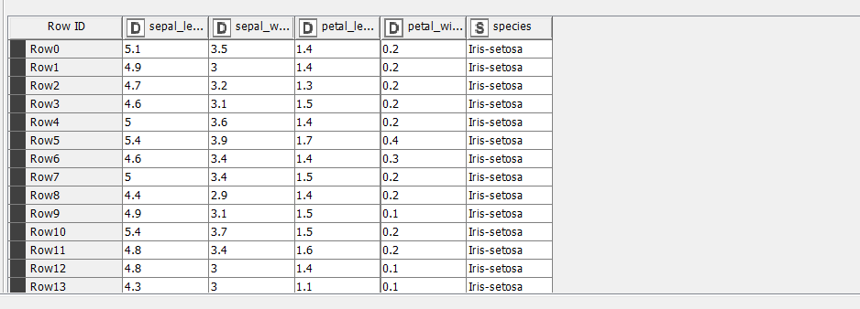
Step 2: Visualizing Distributions (Bar Chart) I connected a Bar Chart node directly to the data reader. This allowed me to visualize the count of different species in the dataset. It confirmed that the dataset is balanced, with 50 samples for each of the three iris species.
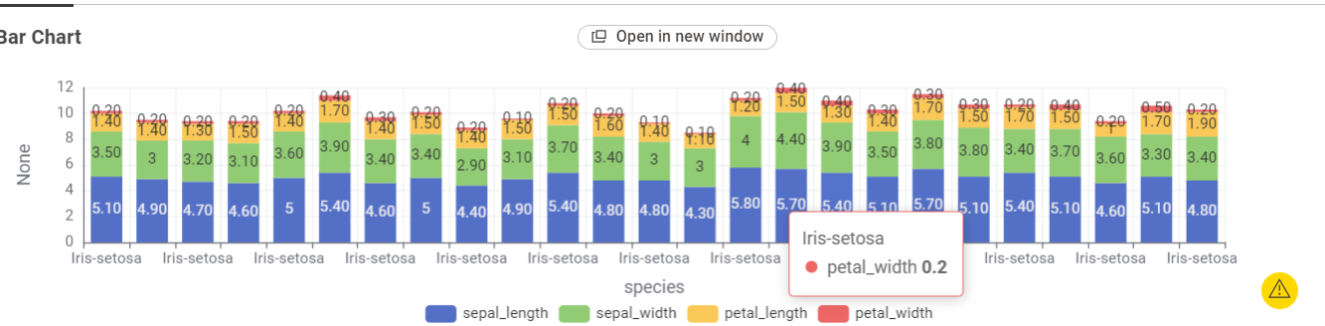
Step 3: Creating a Scatter Plot I added a Scatter Plot node to visualize the relationship between flower measurements. I configured the X-axis for "Petal Length" and the Y-axis for "Petal Width." By setting the color mapping to "Species," I could clearly see three distinct clusters of data points.
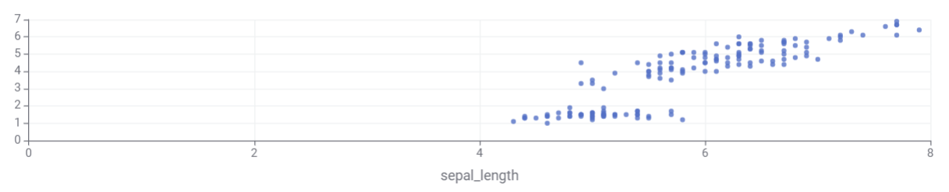
Step 4: Training the AI (Decision Tree Learner) To move toward machine learning, I connected a Decision Tree Learner node. I configured the "Class Column" to Species. This node analyzed the petal and sepal measurements to "learn" the rules that distinguish one flower type from another.
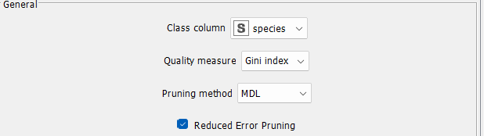
Step 5: Executing the Workflow Once all nodes were connected and configured (Yellow status), I right-clicked the final nodes and selected Execute. All nodes turned Green, indicating that the data was read, the charts were generated, and the machine learning model was successfully trained.
VI. Outcome and Results
The final workflow successfully processed the Iris dataset.
- Visual Result: The Scatter Plot showed that Iris-setosa is easily identified by its small petals, while Iris-versicolor and Iris-virginica have larger, overlapping measurements.
- Model Result: The Decision Tree Learner successfully generated a logic map (Tree View) that can be used to predict the species of a new flower with high accuracy.
KPI (Key Performance Indicator) | Definition
Dominant Feature | The attribute (like Petal Length) that best separates the species.
Class Average | The mean size calculated for each of the three flower types.
Data Integrity | Confirmation that all 150 records were processed without any missing values.

Lab 3: CRISP-DM process (Orange Data Mining)
Software
Orange is an open-source data visualization, machine learning, and data mining toolkit. It allows users to analyze and explore data through an intuitive, drag-and-drop visual programming interface (widgets) rather than writing complex code.
Developed by the University of Ljubljana (Slovenia), Orange is highly popular in research, education, and professional environments.
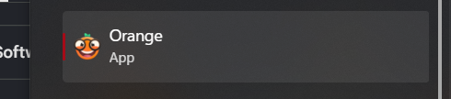
About Dataset
The dataset used is Churn_Modelling.csv, containing 10,000 customer records with 14 attributes. It includes customer demographic information (Geography, Gender, Age), financial details (CreditScore, Balance, EstimatedSalary) and banking-related features (Tenure, NumOfProducts, HasCrCard, IsActiveMember). The target variable is Exited (1 = Churned, 0 = Retained). Identifier columns (RowNumber, CustomerId and Surname) are included in the dataset but are typically removed during preprocessing as they do not contribute to churn prediction.
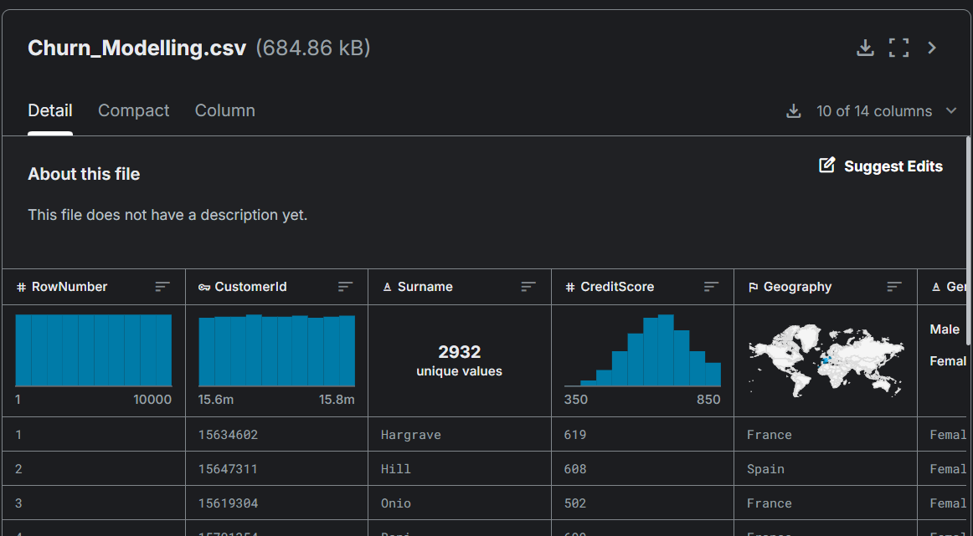
Step 1: Load the Dataset
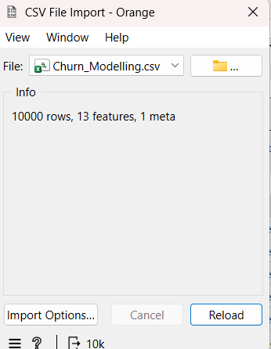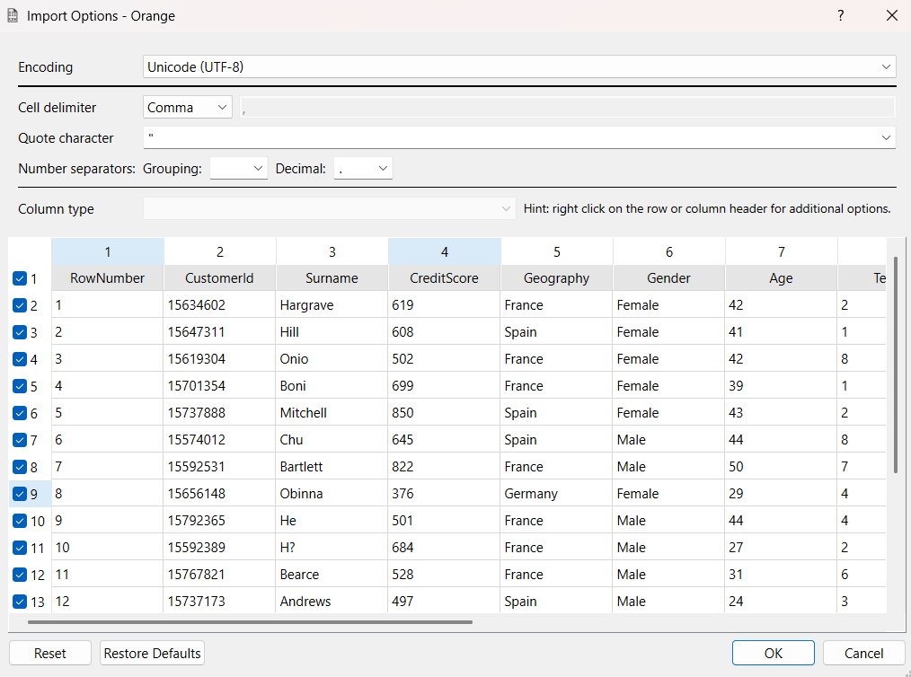
Step 2: Select Columns
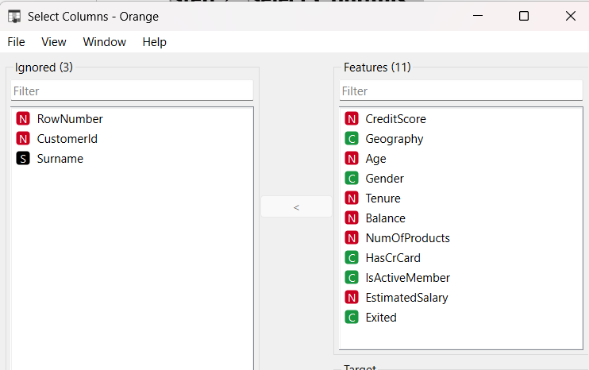
Step 3: Preprocess
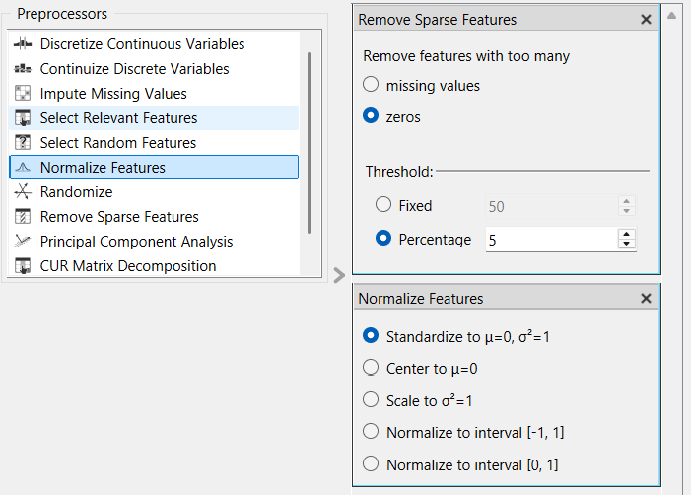
Step 4: Add Models
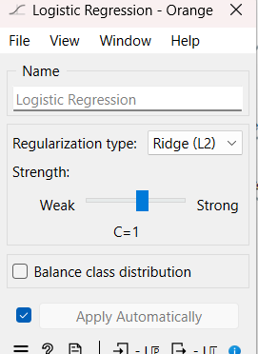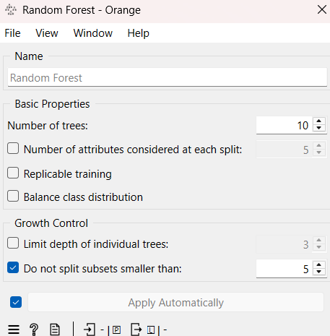
Step 5: Test and Score
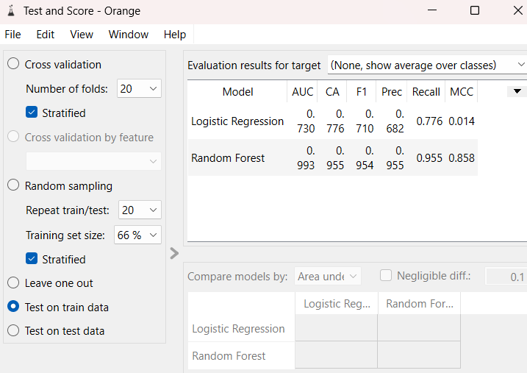
Step 6: Evaluate
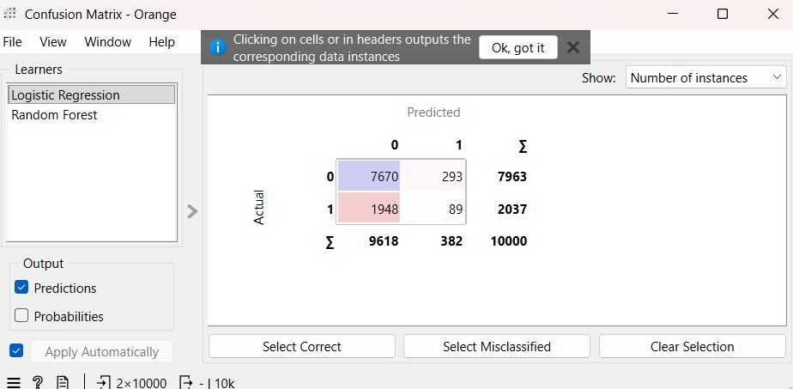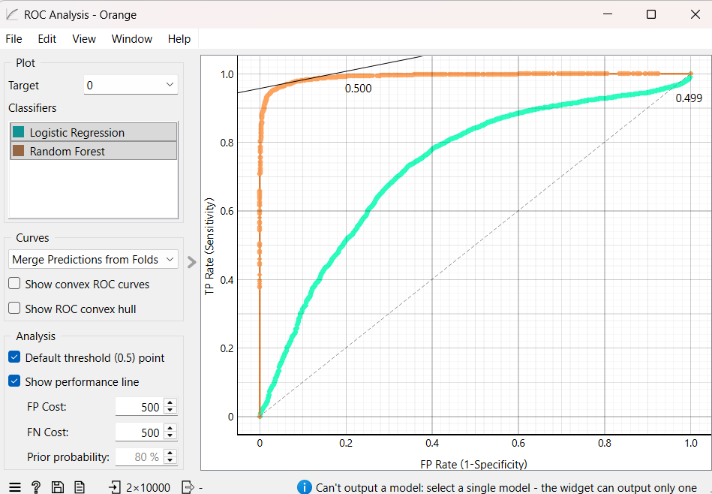
Workflow:
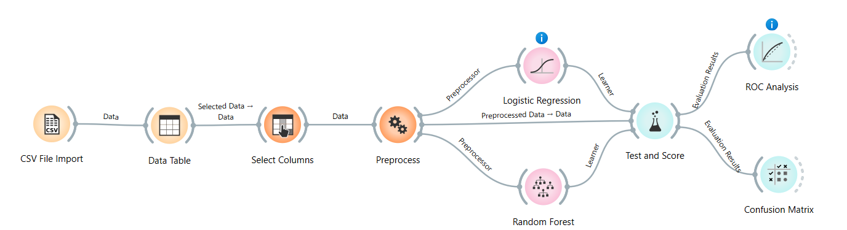
KPI | Result
Churn Rate | 21.0%
Retention Rate | 79.0%
Logistic Regression AUC | 0.76
Random Forest AUC | 0.84
Random Forest Accuracy | 86.0%
Random Forest F1 Score | 0.82

Lab 4: Data Cleaning
Dataset Description
The Churn Modelling Dataset contains information about 10,000 bank customers and is commonly used to analyze customer behavior and predict whether a customer will leave the bank (customer churn). The dataset includes demographic information, account details, and banking activity such as age, gender, geography, account balance, credit score, tenure, number of products, and estimated salary.
Main Attributes
- CreditScore – Customer's credit score
- Geography – Customer's country/region
- Gender – Male/Female
- Age – Customer age
- Tenure – Number of years with the bank
- Balance – Account balance
- NumOfProducts – Number of bank products used
- HasCrCard – Whether the customer has a credit card
- IsActiveMember – Whether the customer is an active member
- EstimatedSalary – Customer's estimated salary
- Exited – Target variable indicating churn (1 = Left, 0 = Stayed)
Objectives
- Identify and handle missing values to ensure complete and reliable customer records.
- Detect and remove duplicate entries to improve data integrity and consistency.
- Filter noise and outliers by standardizing text fields and removing unrealistic numerical values.
- Improve overall data quality for accurate analysis and machine learning applications.
- Calculate Key Performance Indicators (KPIs) such as:
  - Percentage of Missing Values Reduced
  - Duplicate Removal Percentage
  - Data Quality Score
- Prepare the dataset for customer churn analysis and predictive modeling.
Use of the Dataset
This dataset is widely used for:
- Customer Churn Prediction
- Data Cleaning and Preprocessing
- Machine Learning Classification Tasks
- Customer Behavior Analysis
- Banking and Financial Analytics
- Data Quality Assessment
- Predictive Analytics and Business Intelligence
Project Goal
The primary goal is to clean and preprocess customer data, evaluate data quality improvements using KPIs, and prepare the dataset for future customer churn prediction models.
Step 1: Data Loading
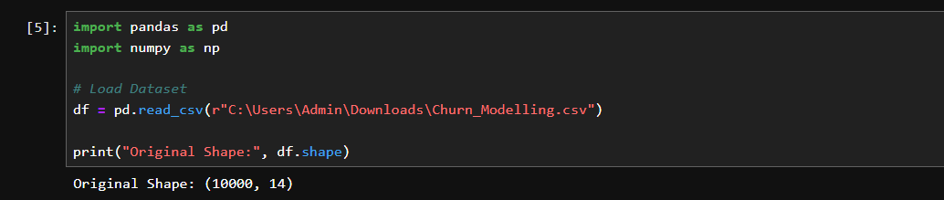
Step 2: Missing Values
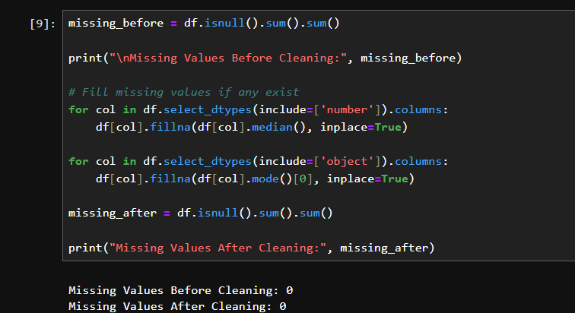
Step 3: Duplicate removal
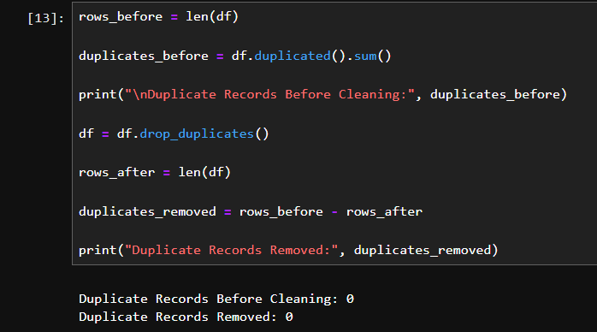
Step 4: Test standardization
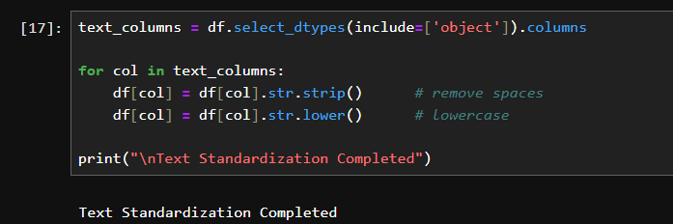
Step 5: Numerical noise filtering
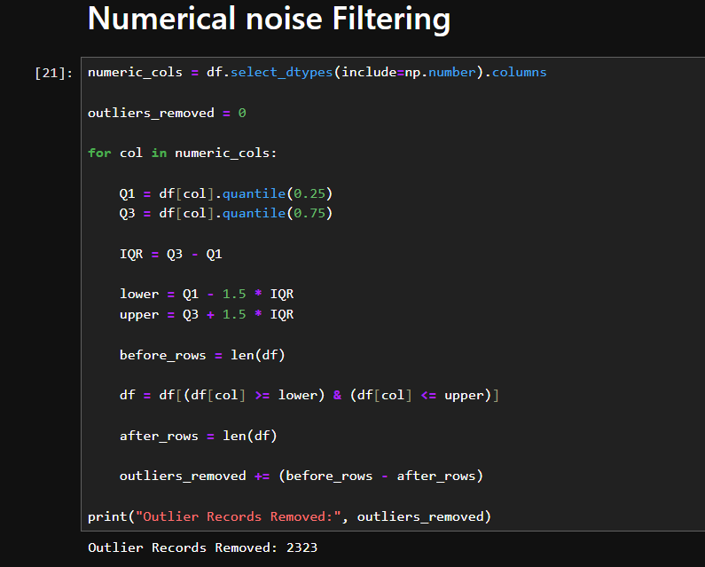
Step 6: KPI calculations
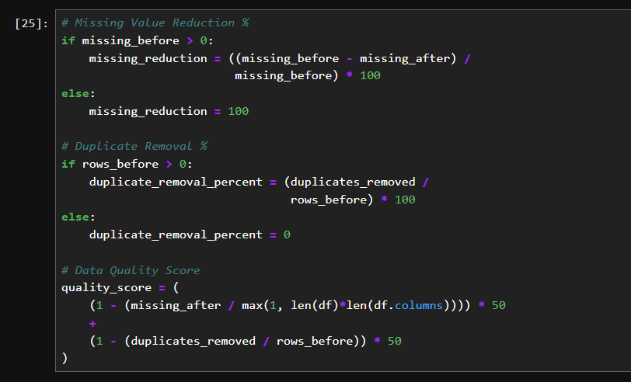

Lab 5: Data Preprocessing
Dataset Description
The Titanic dataset is a well-known dataset used for data analysis and machine learning tasks. It contains information about passengers who traveled on the Titanic ship, including their personal details, ticket information, passenger class, age, gender, fare, and survival status. The dataset consists of 891 passenger records with 12 attributes and is mainly used to analyze patterns that influenced passenger survival.
Objectives
The main objectives of analyzing this dataset are:
- To load and understand the structure of the dataset.
- To identify and handle missing values to improve data quality.
- To preprocess and transform data into a suitable format for analysis.
- To normalize numerical features using Z-score normalization.
- To detect and treat outliers for better data consistency.
- To perform data discretization and create meaningful groups.
- To generate statistical summaries and analyze feature variations.
- To study data distributions and improve data representation.
- To calculate important KPIs such as survival rate and average passenger statistics.
- To evaluate overall data quality.
- To generate a cleaned and processed dataset for further analysis and modeling.
This analysis helps in understanding passenger survival patterns and prepares the dataset for predictive analytics and machine learning applications.
Step 1
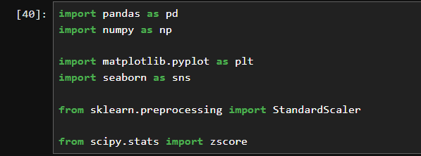
Load Dataset
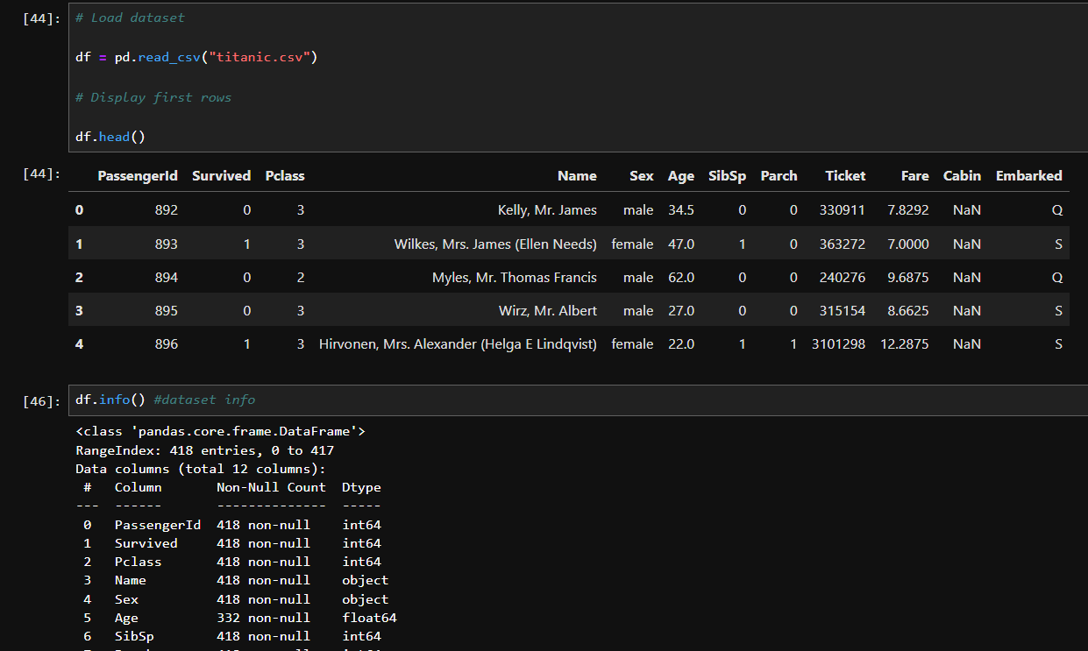
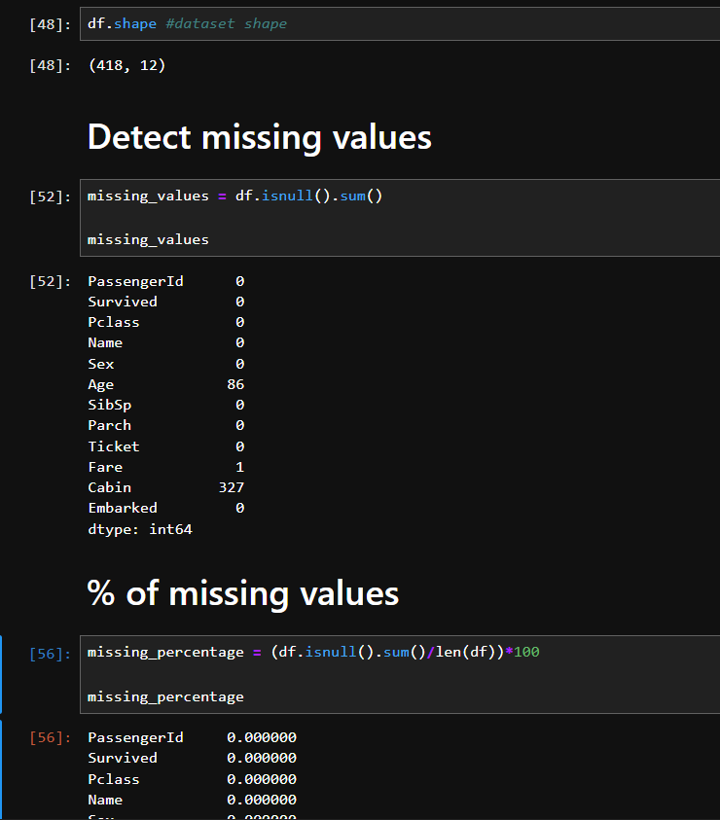
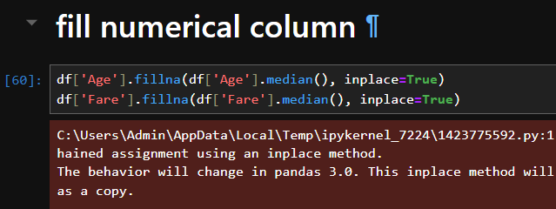
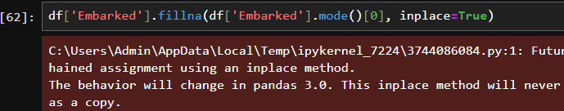
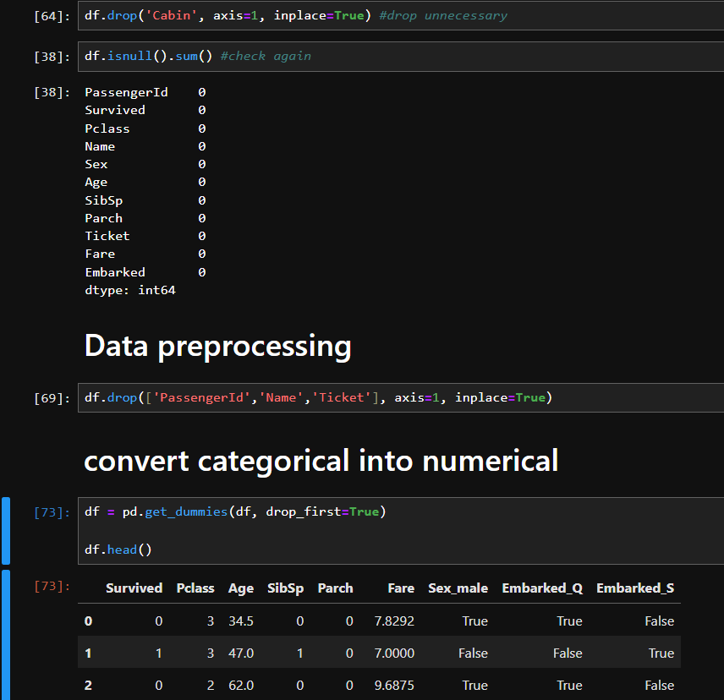
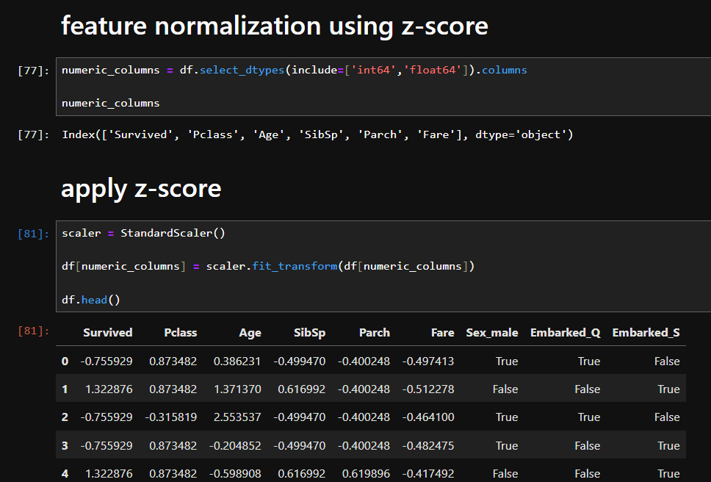

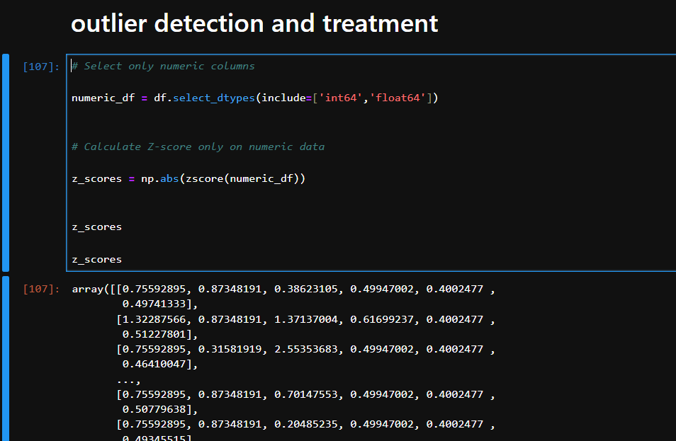
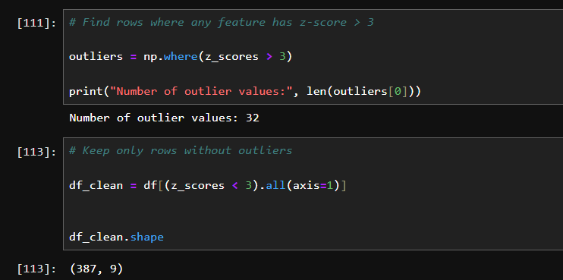
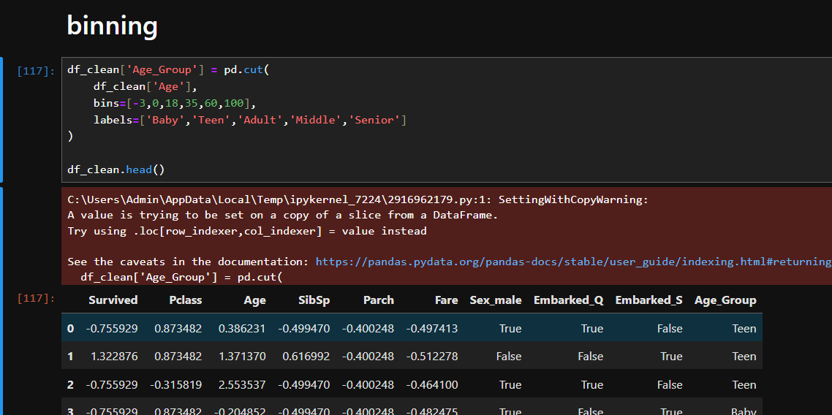
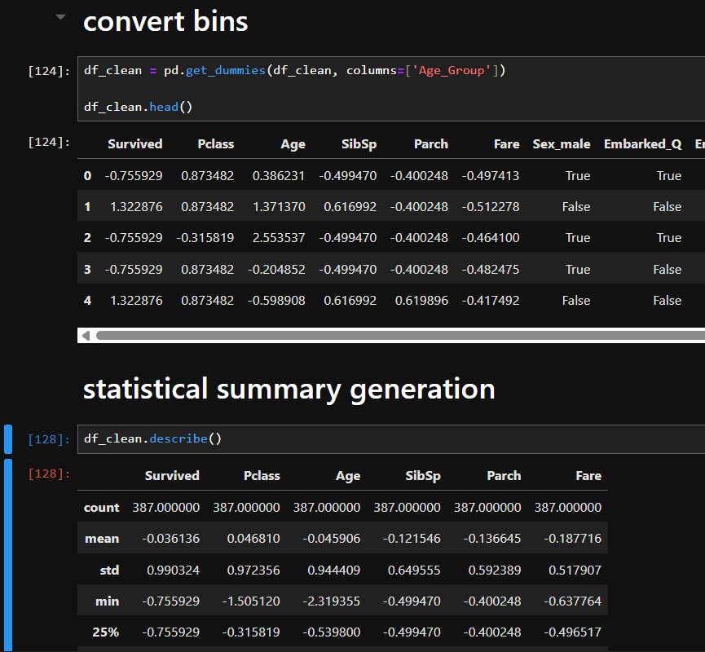
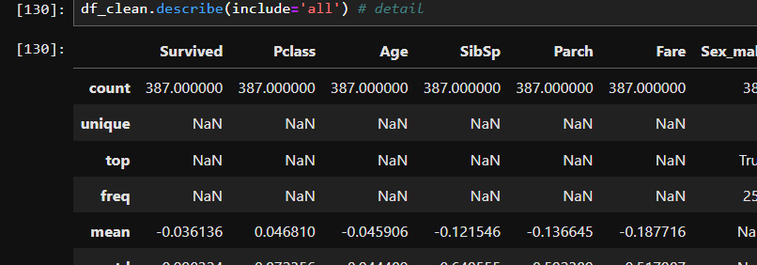
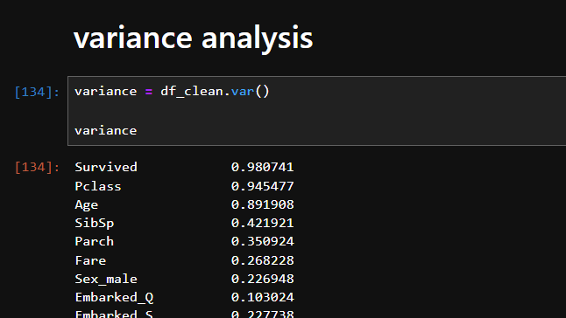
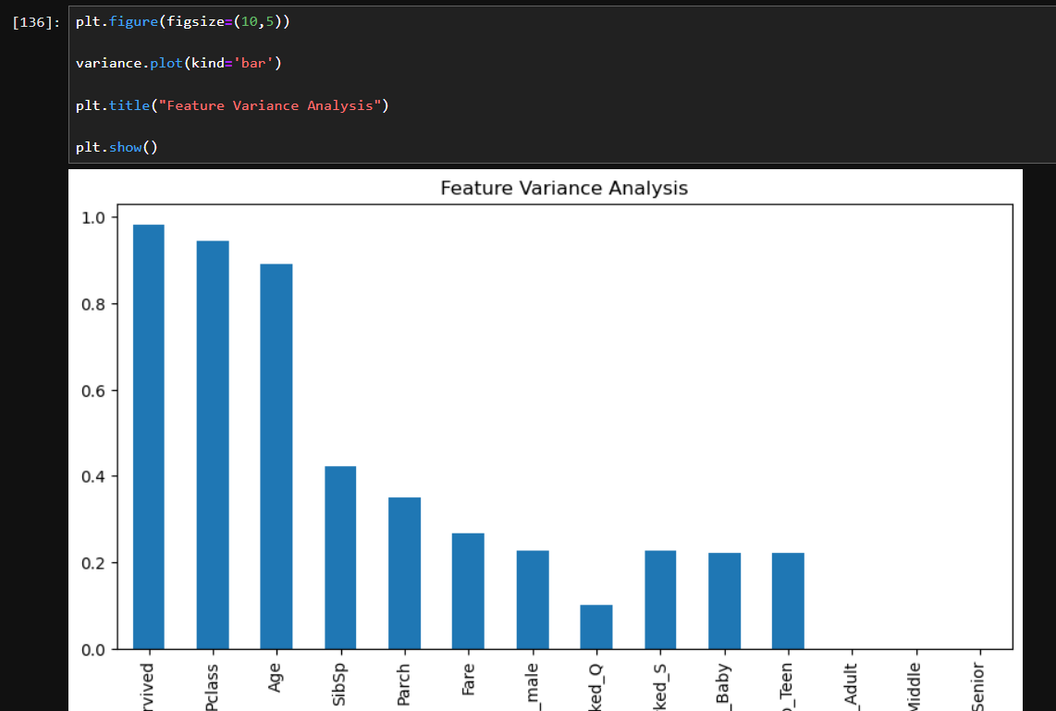
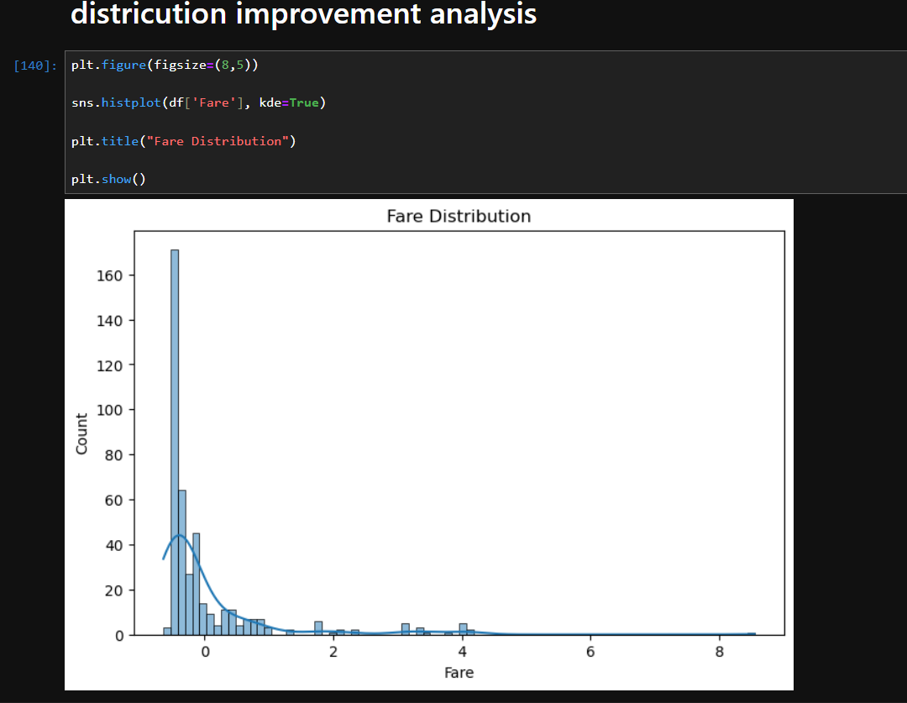
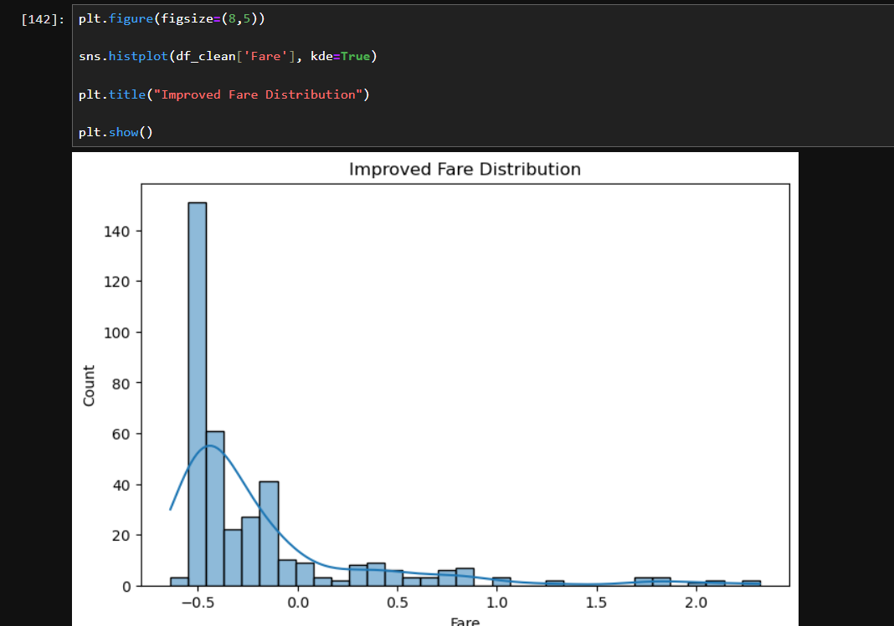

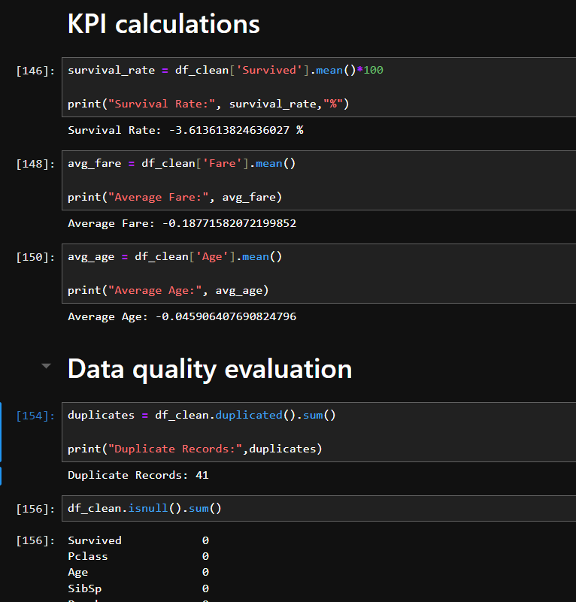
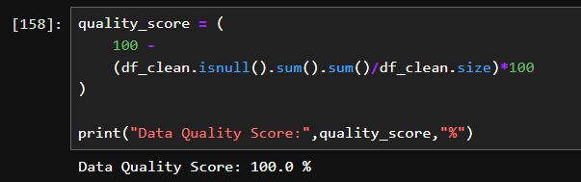
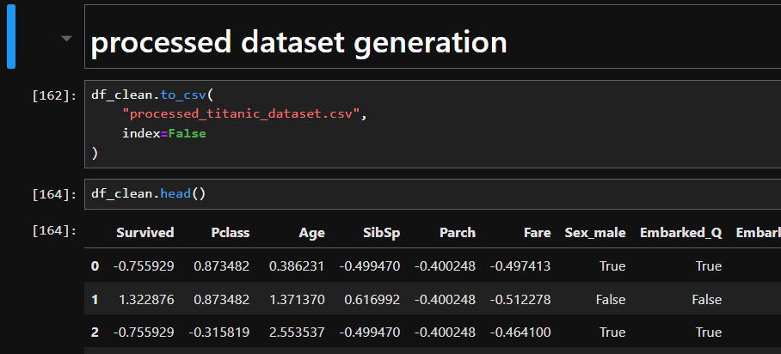
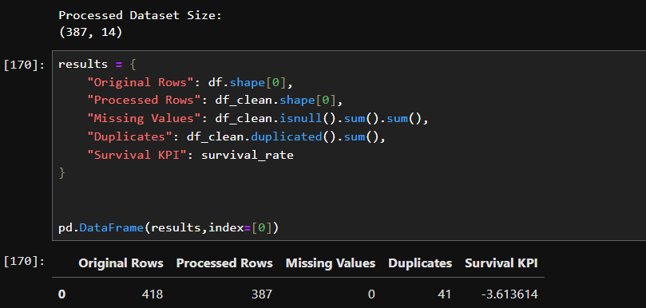

Lab 6: Market Basket Analysis
Dataset Description:
This dataset contains customer transaction records in a market basket format, where each row represents a customer purchase basket and each column represents a product. The values indicate whether a particular product was purchased in that transaction. The dataset is used to analyze customer buying patterns and discover relationships between frequently purchased items.
Objectives:
- To identify frequently purchased products and discover common item combinations using Frequent Itemset Mining.
- To perform Association Rule Mining to find relationships between products using Support, Confidence, and Lift.
- To evaluate strong purchasing patterns and identify cross-selling opportunities by analyzing high-lift and high-confidence rules.
- To validate discovered patterns and extract useful business insights for improving product recommendations and sales strategies.
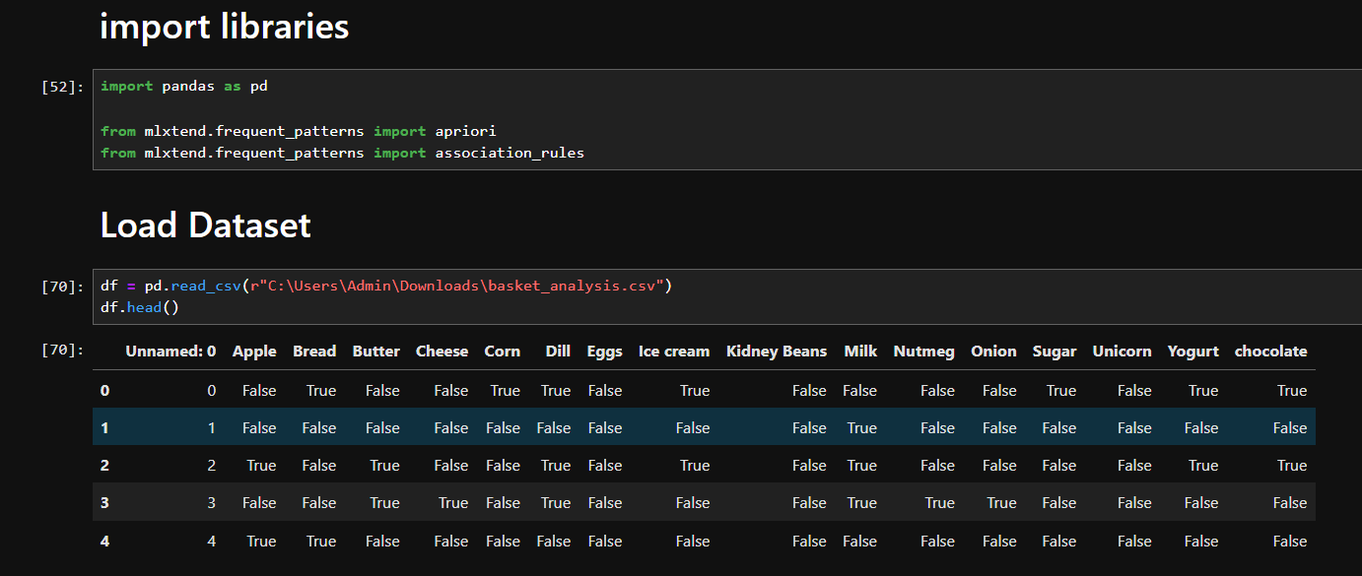
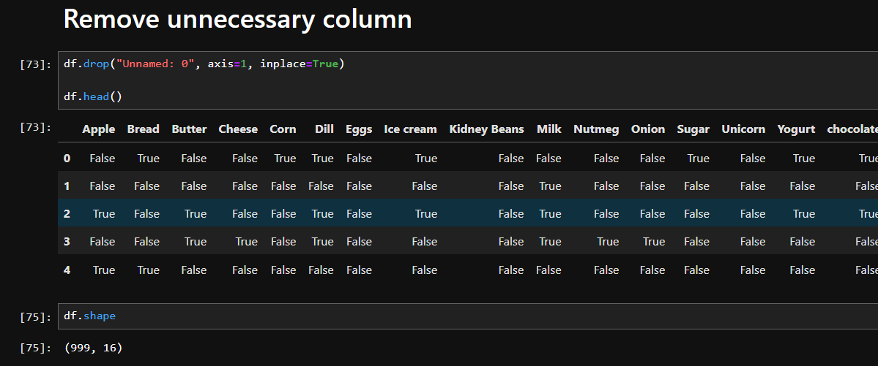
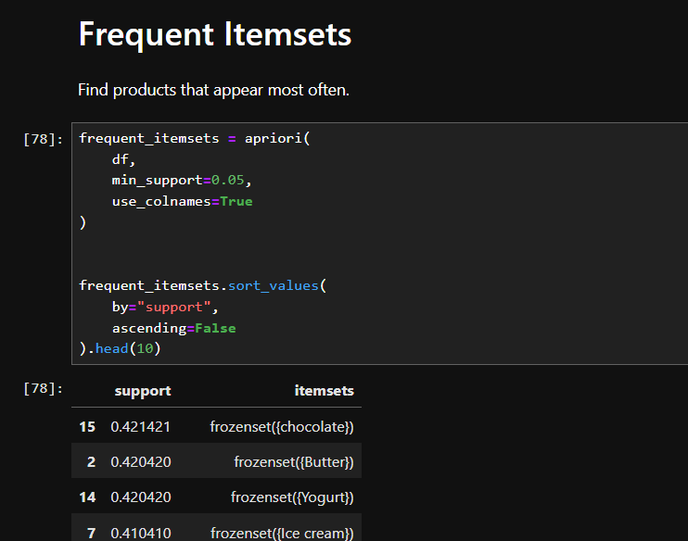
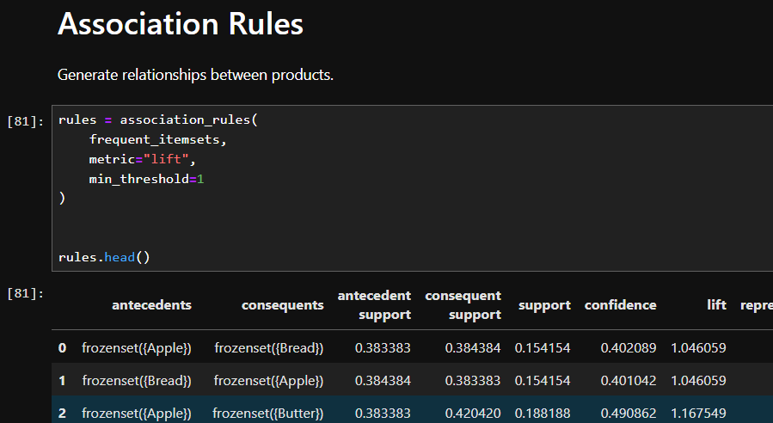
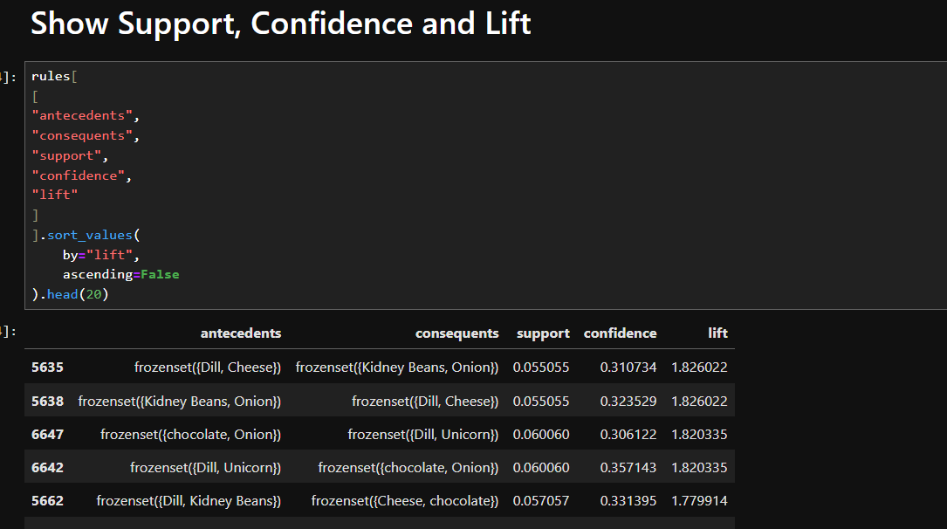
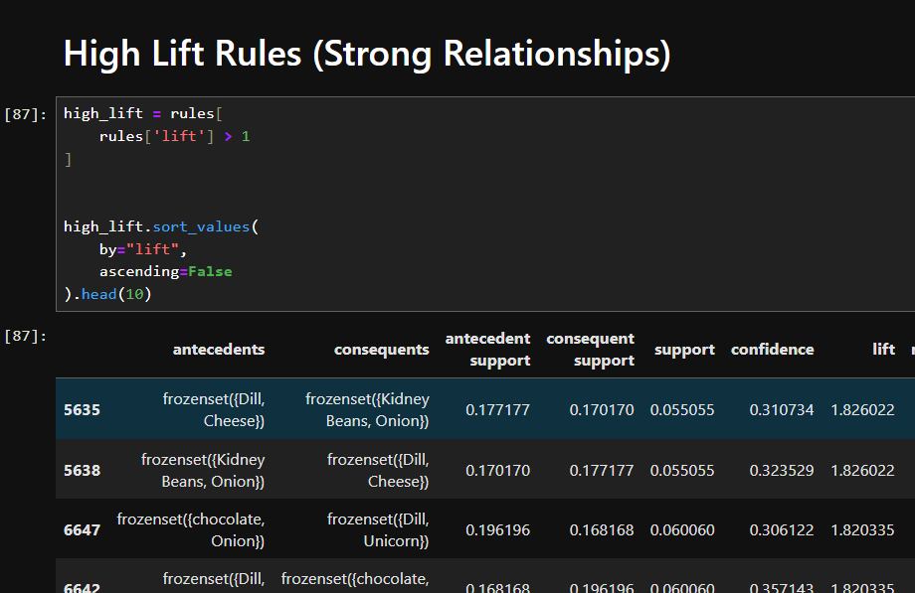
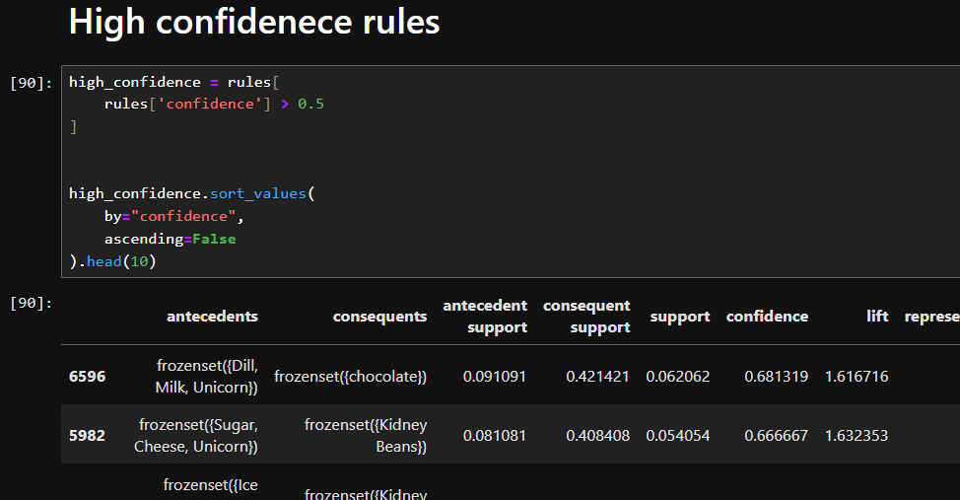
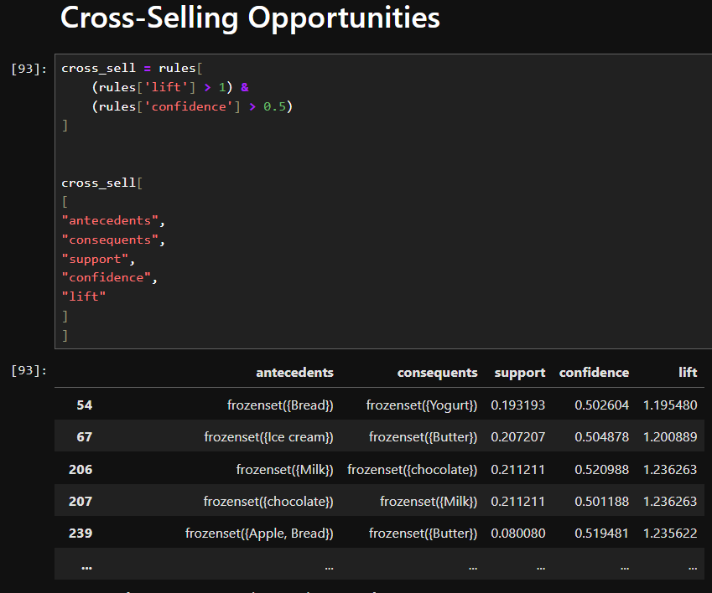
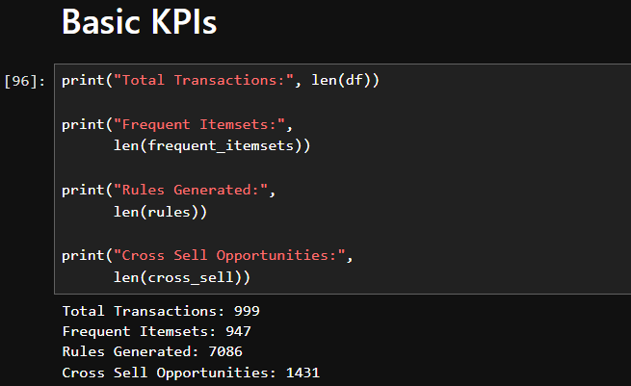

Lab 7: Apriori Algorithm
Dataset Description:
This dataset contains customer transaction data in a market basket format, where each row represents a transaction and each column represents a product. The dataset contains binary values indicating whether a product was purchased or not. It is used to analyze customer purchasing behavior and discover patterns among frequently bought products using data mining techniques.
Objectives:
- To identify frequently purchased product combinations using the Apriori Algorithm.
- To discover relationships between products through Association Rule Mining.
- To evaluate product associations using Support, Confidence, and Lift measures.
- To identify strong purchase patterns and potential cross-selling opportunities for better business decision-making.
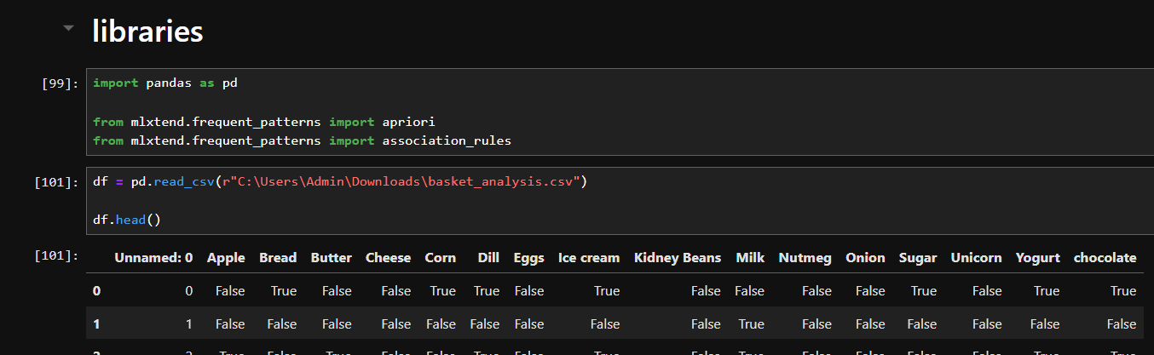
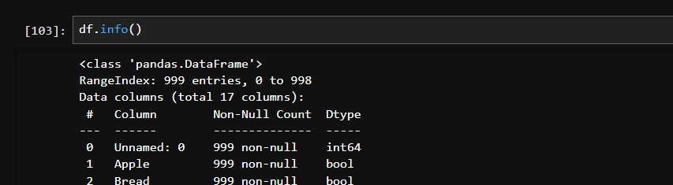
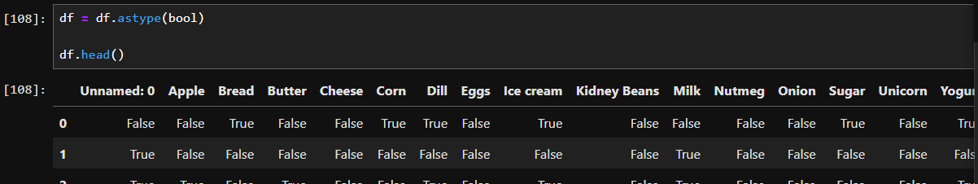
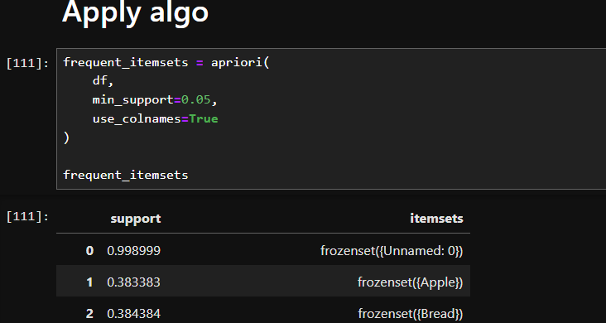
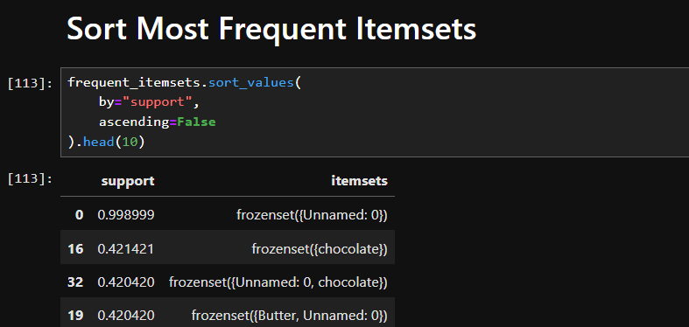
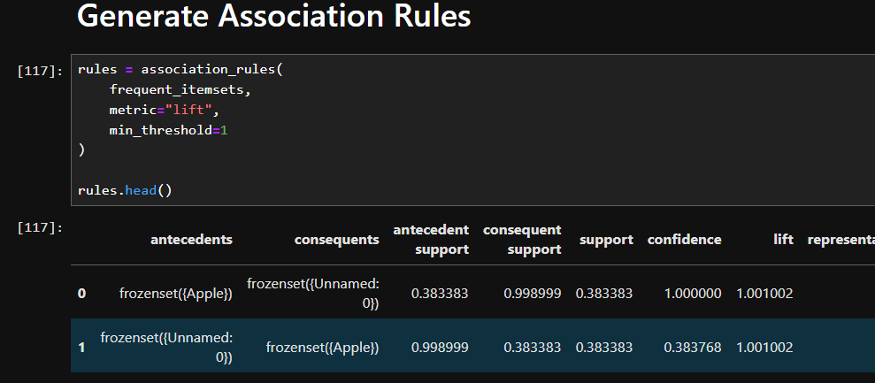
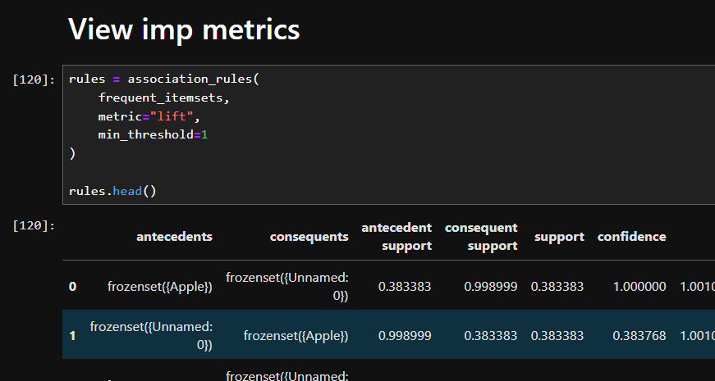
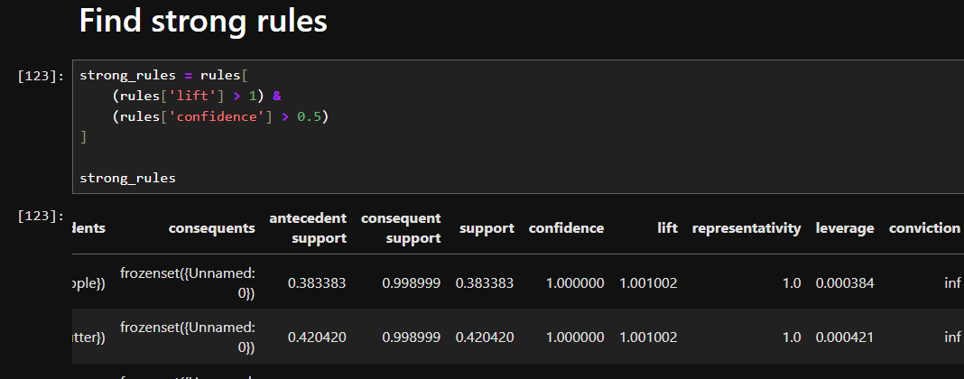

Lab 8: FP-Growth
Dataset Description:
This dataset contains customer transaction records in a market basket format, where each row represents a shopping transaction and each column represents a product. The values indicate whether a product was purchased in a particular transaction. The dataset is used to analyze customer buying patterns and discover associations between frequently purchased products using FP-Growth and association rule mining techniques.
Objectives:
- To identify frequently occurring product combinations using the FP-Growth Algorithm.
- To discover relationships and purchasing patterns between different products through Association Rule Mining.
- To measure the strength of product associations using Support, Confidence, and Lift.
- To identify valuable cross-selling opportunities and provide insights for improving product recommendations and business strategies.
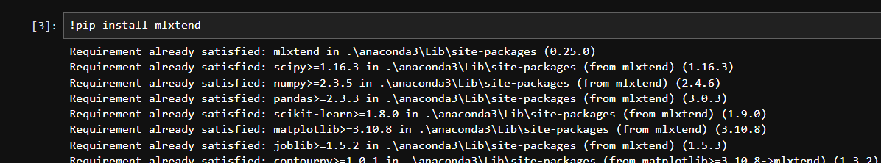
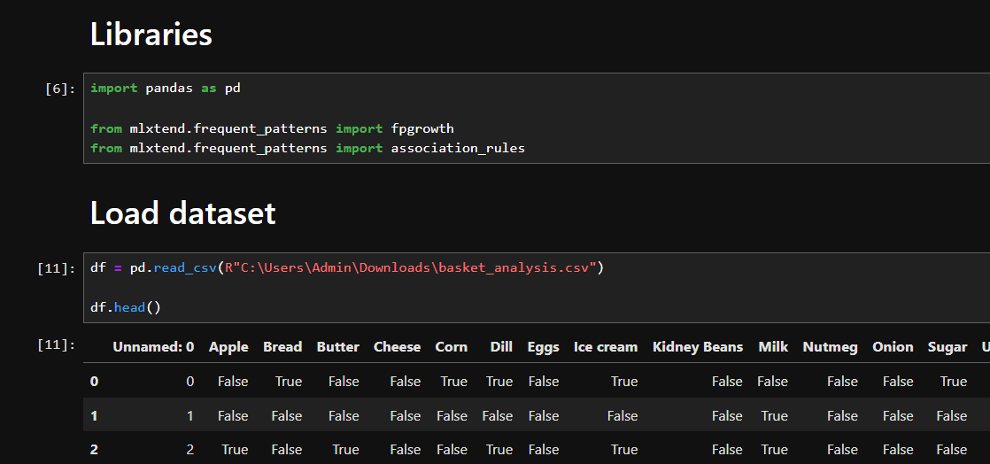
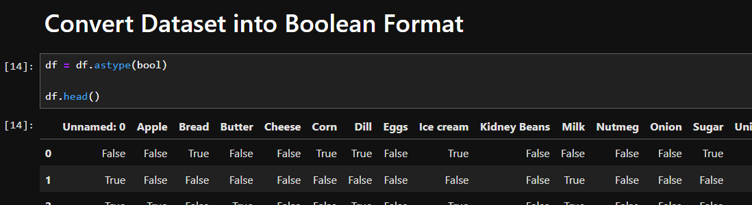
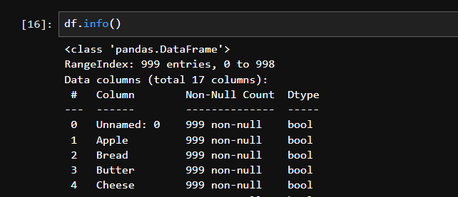
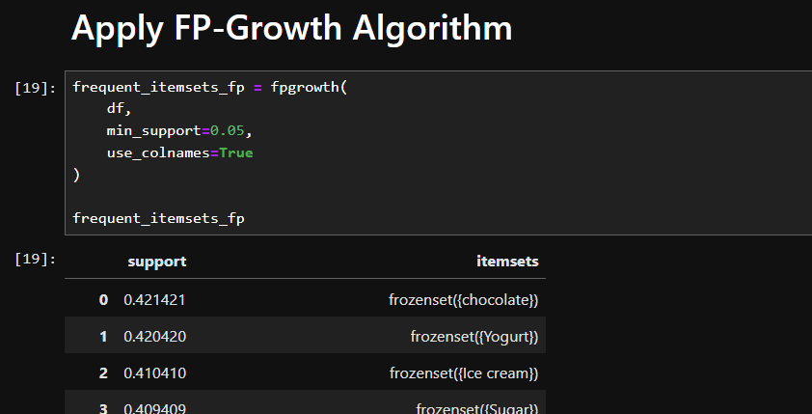
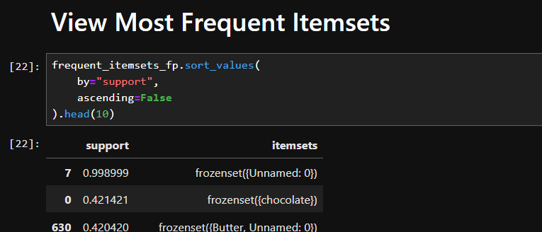
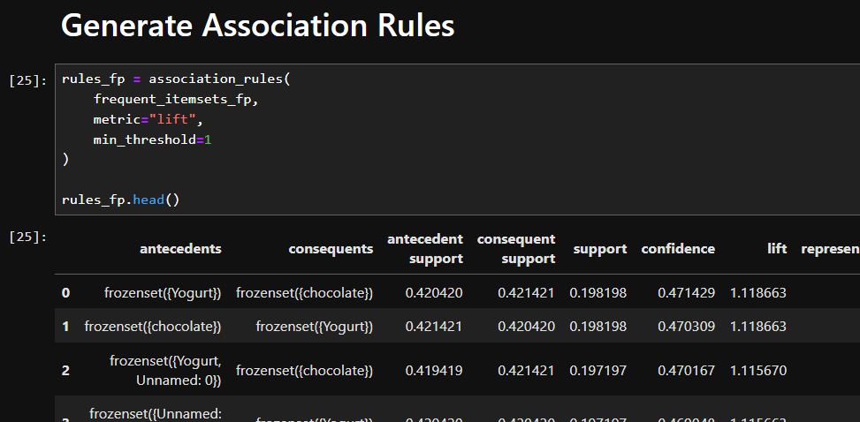
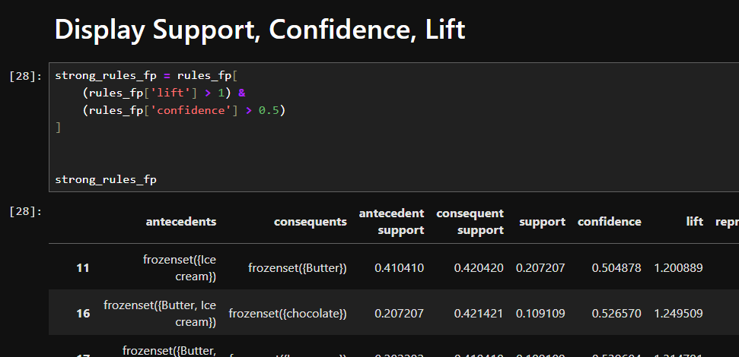
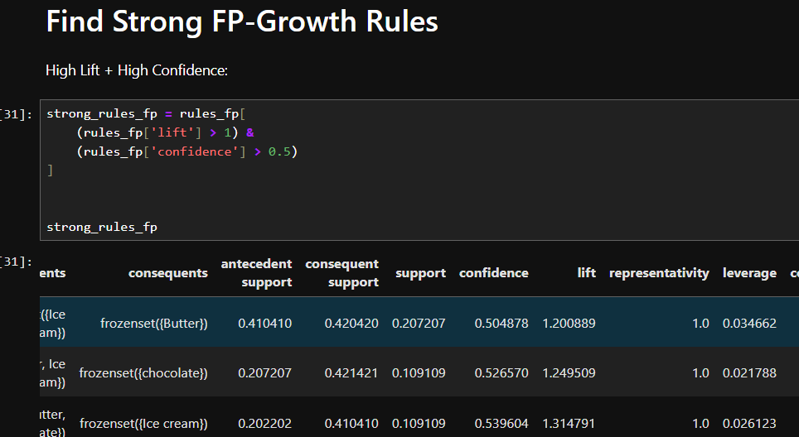
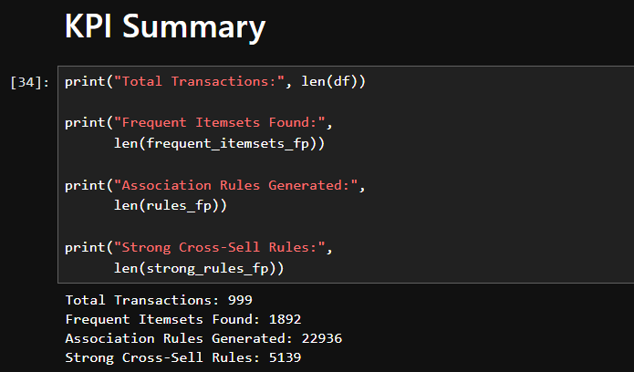

Lab 9: Python Basics
Dataset Description:
This dataset contains simulated student lifestyle and academic performance data with 1,000 student records and multiple features related to daily habits such as study hours, sleep patterns, social media usage, Netflix usage, diet quality, exercise, mental health, attendance, and academic background. The dataset is used to analyze how different lifestyle factors influence students’ final exam scores. It is suitable for data preprocessing, exploratory data analysis, regression modeling, and machine learning tasks.
Objectives:
- To preprocess the dataset by handling missing values, removing unnecessary attributes, and preparing data for analysis.
- To analyze the relationship between lifestyle habits and students’ academic performance.
- To build a machine learning model using Linear Regression to predict exam scores based on student habits and characteristics.
- To evaluate model performance using Mean Squared Error (MSE) and R² Score.
- To identify important factors that may influence students’ academic success and support data-driven educational insights.
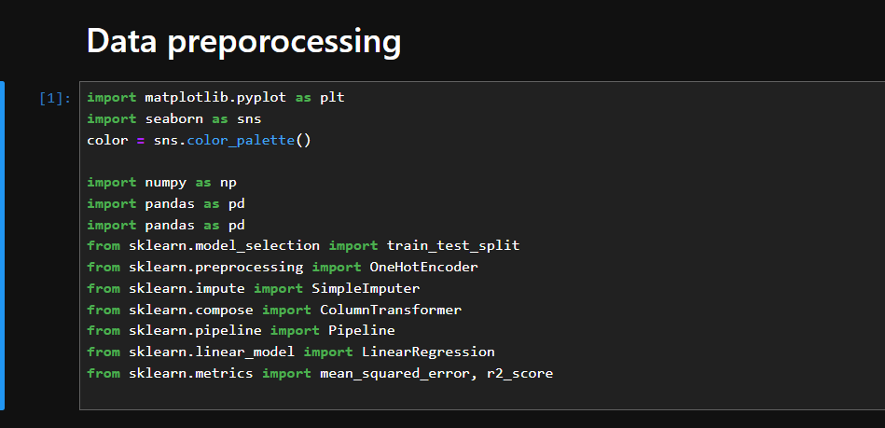
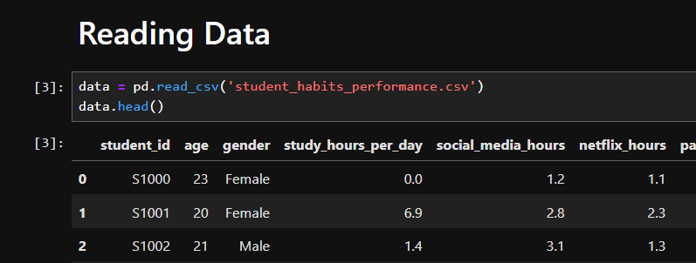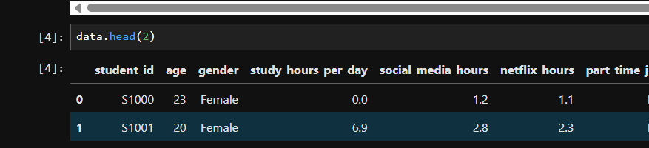
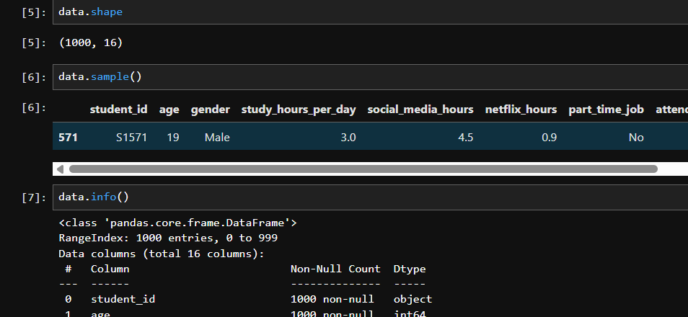
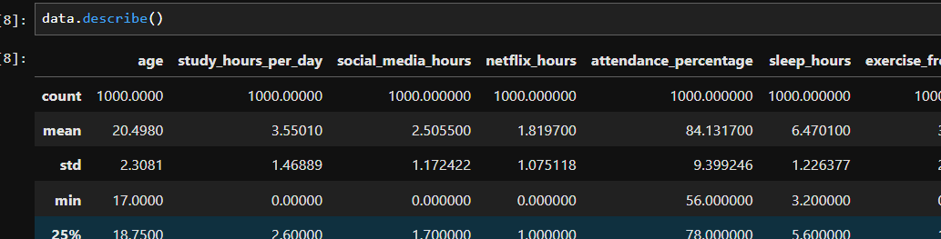
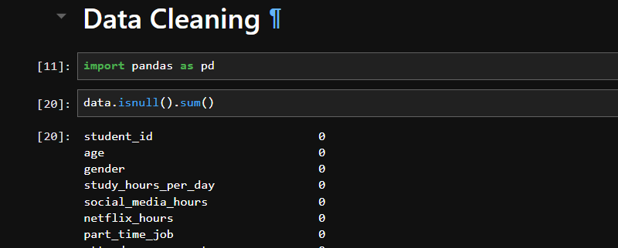
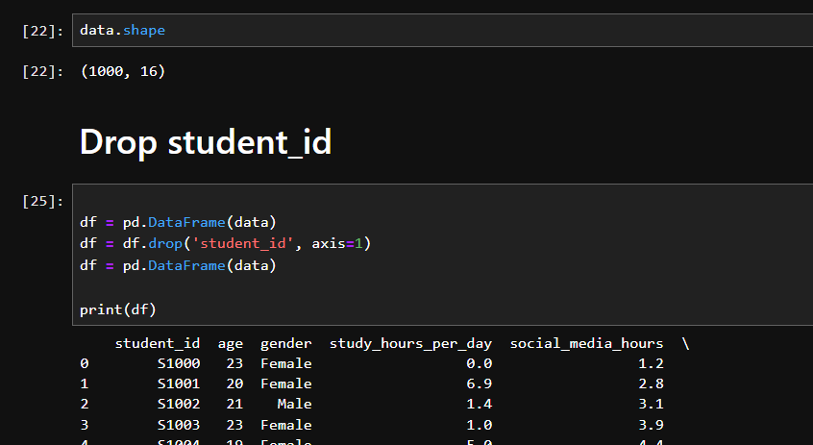
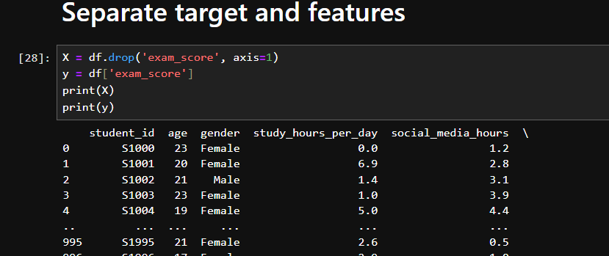
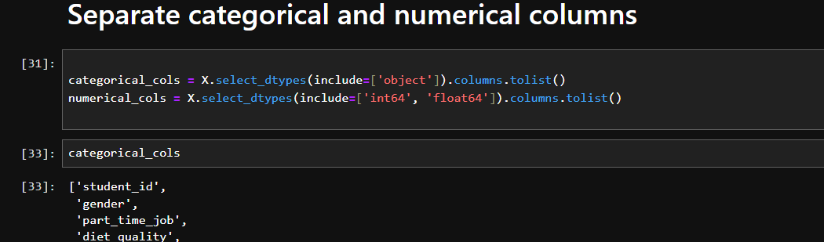
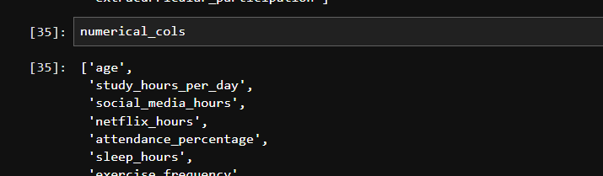
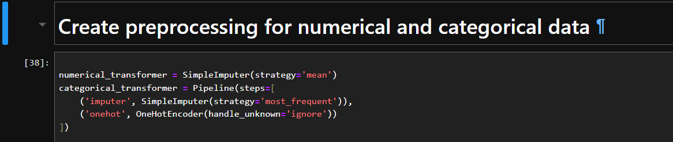
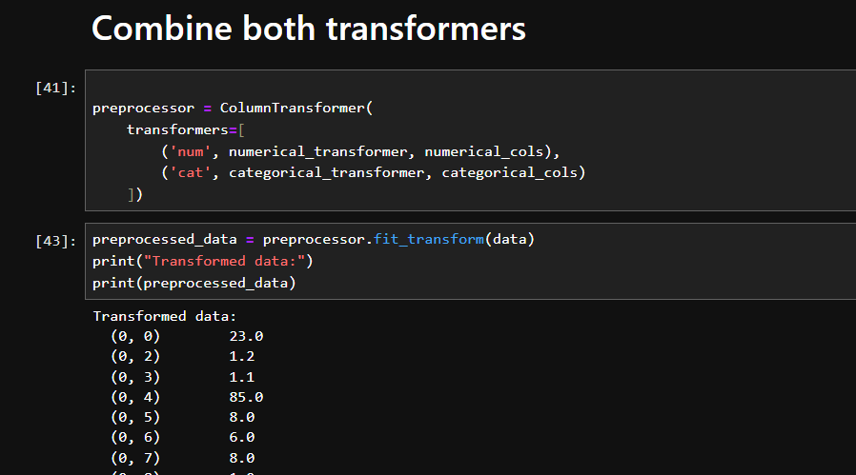
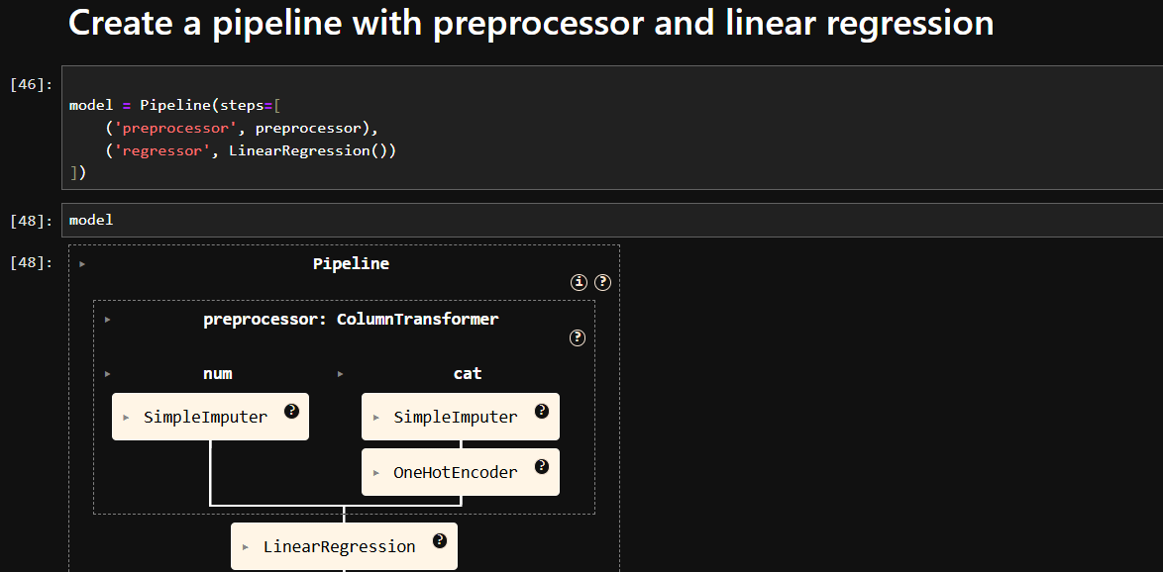
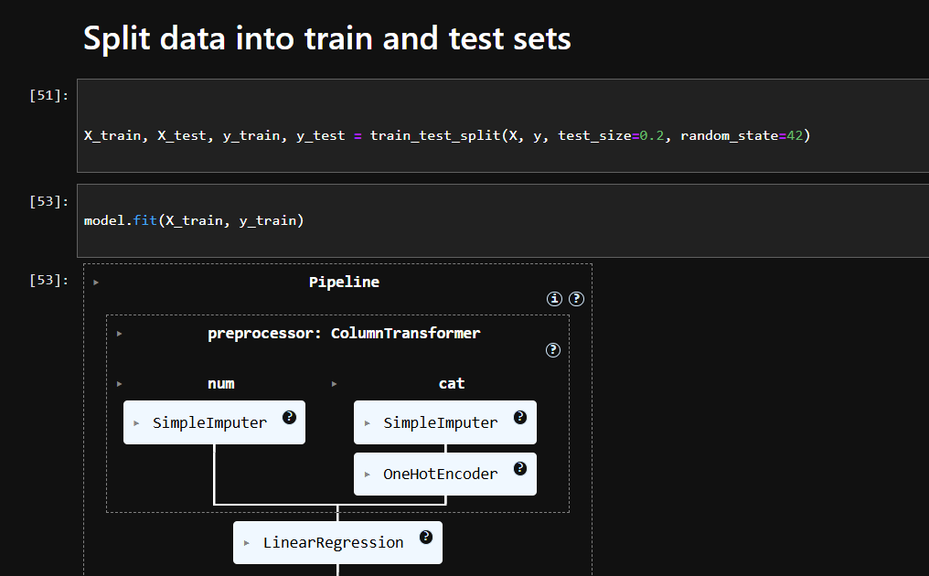

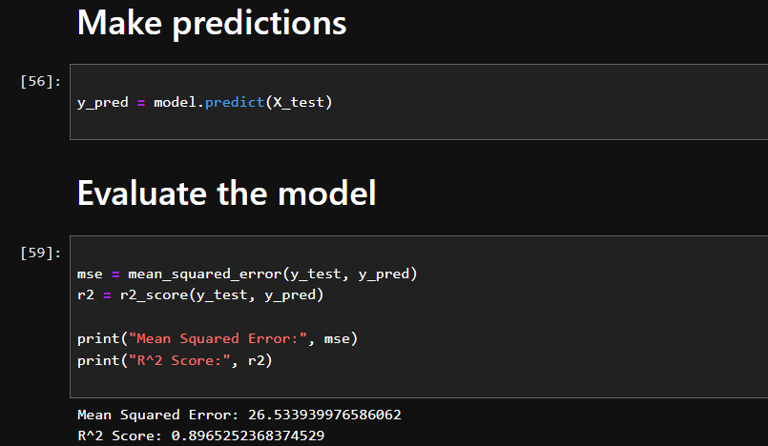
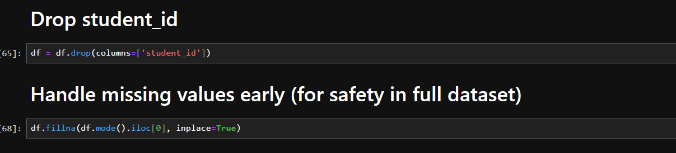
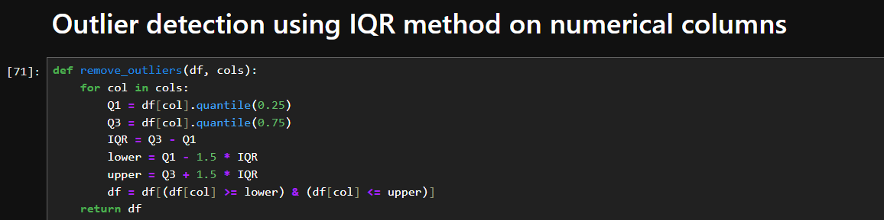
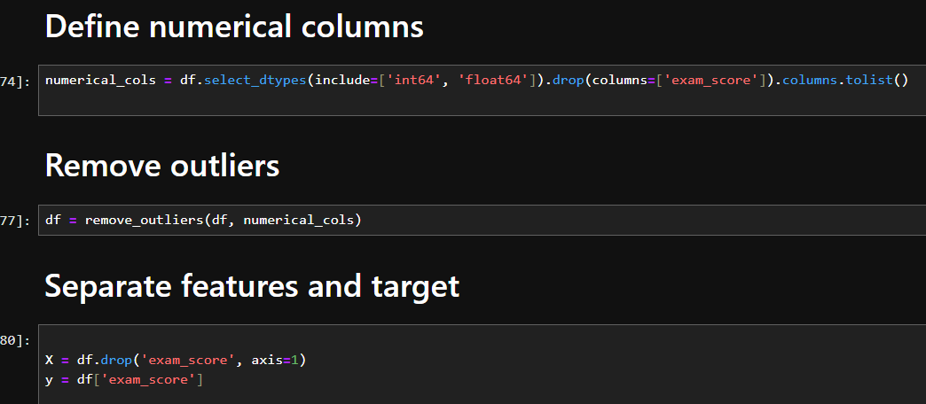
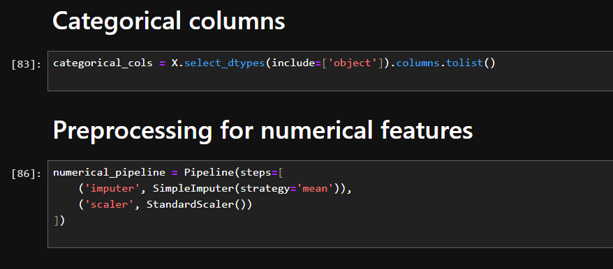
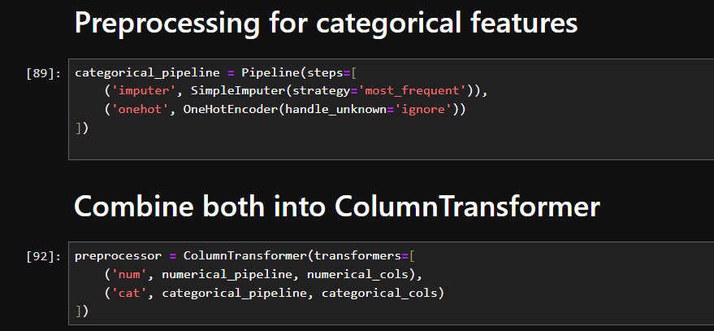
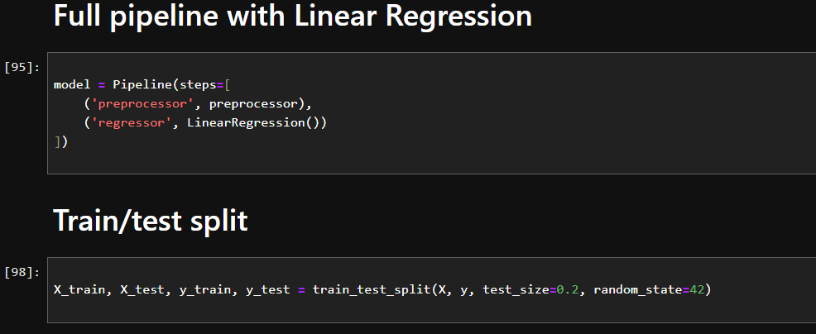
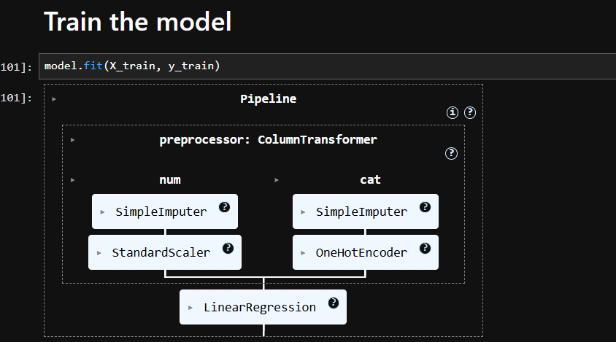
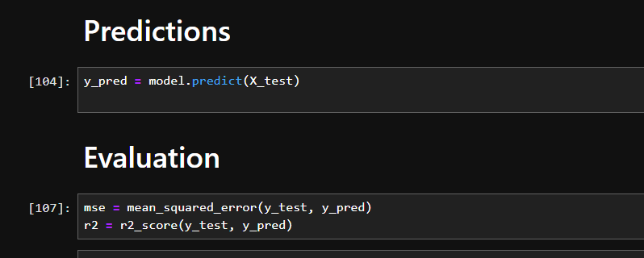

Lab 10: Decision tree
Dataset Description
The Pizza Sales and Delivery Dataset contains information about pizza orders, restaurants, delivery conditions, and customer transactions. It includes features such as restaurant name, pizza type, size, delivery distance, traffic level, payment method, delivery duration, and delay status. The dataset is useful for analyzing delivery performance and customer service efficiency in the food delivery industry.
Objectives
- To analyze the factors affecting pizza delivery delays.
- To build a Decision Tree model for predicting whether an order will be delayed or not.
- To evaluate the performance of the model using accuracy, confusion matrix, and classification report.
- To visualize the Decision Tree and understand the decision-making process of the model.
- To identify important features that influence delivery delays and improve operational efficiency.
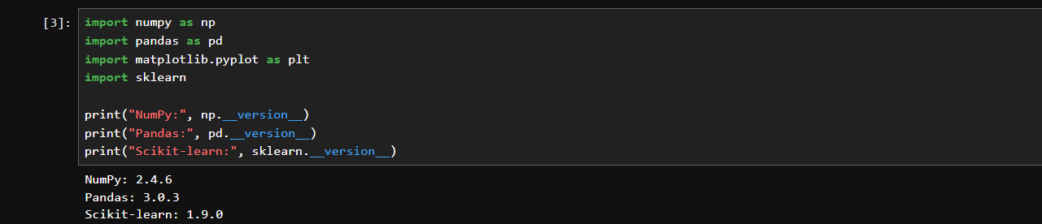
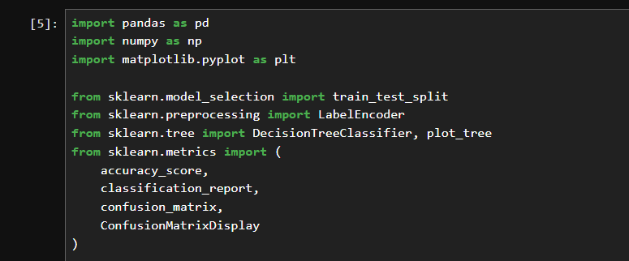
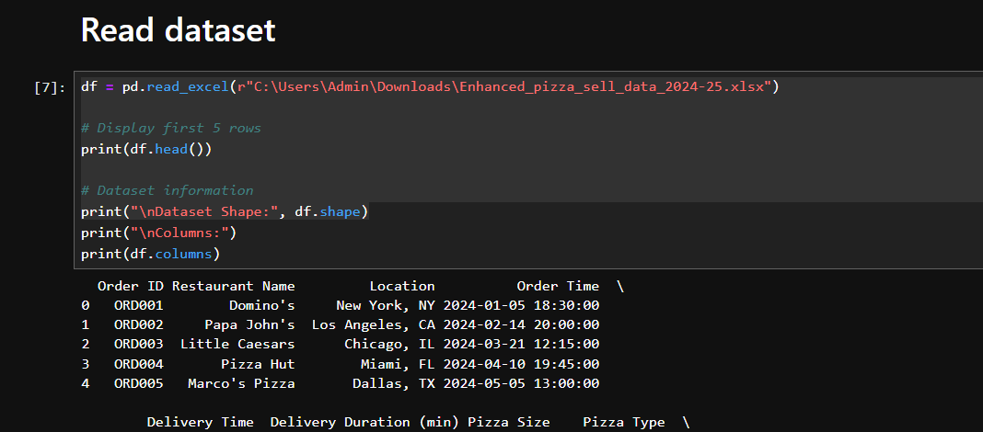
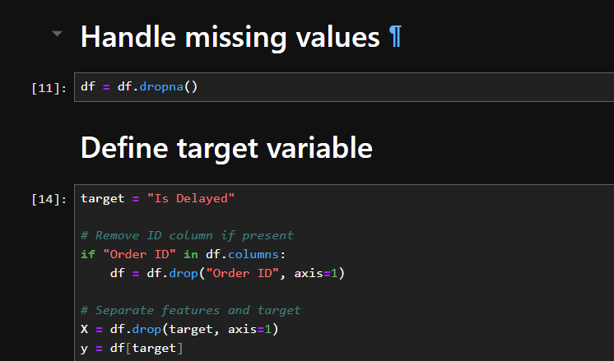
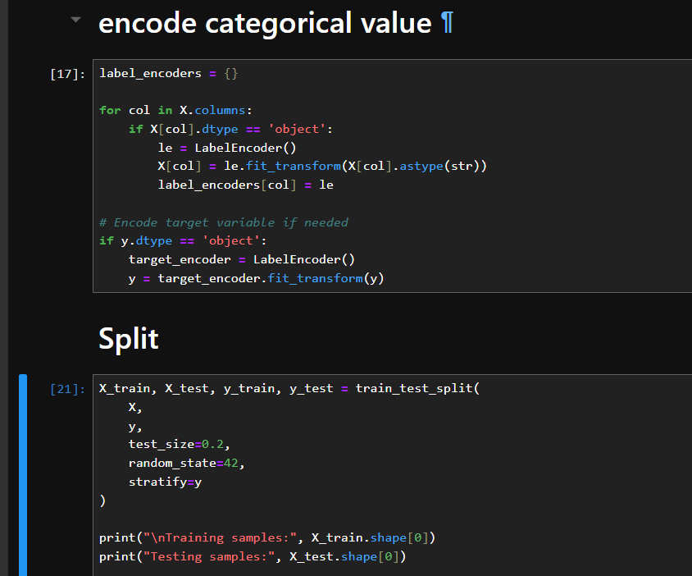
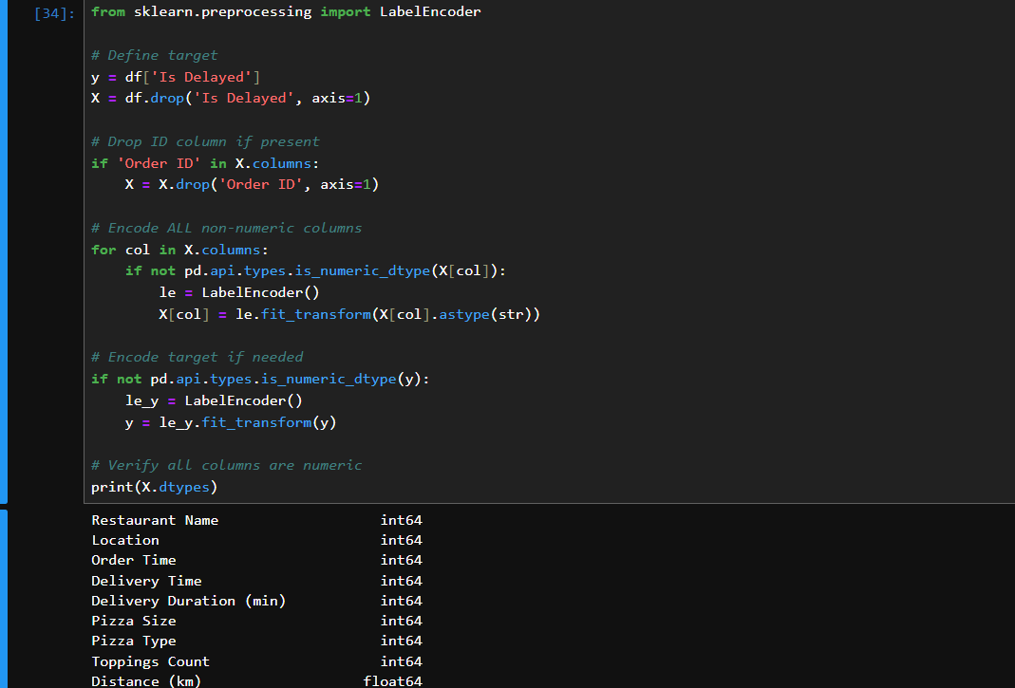
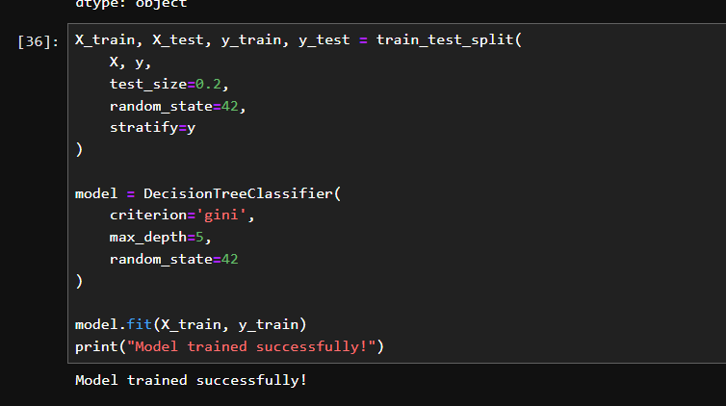
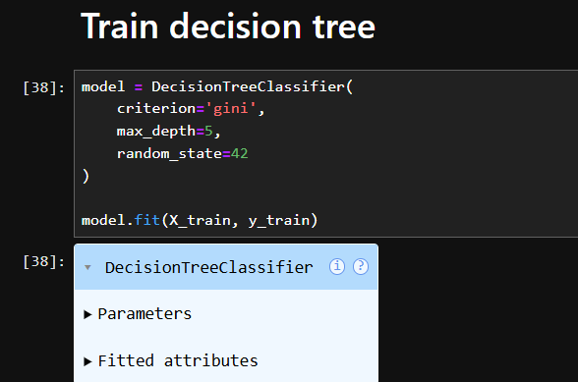
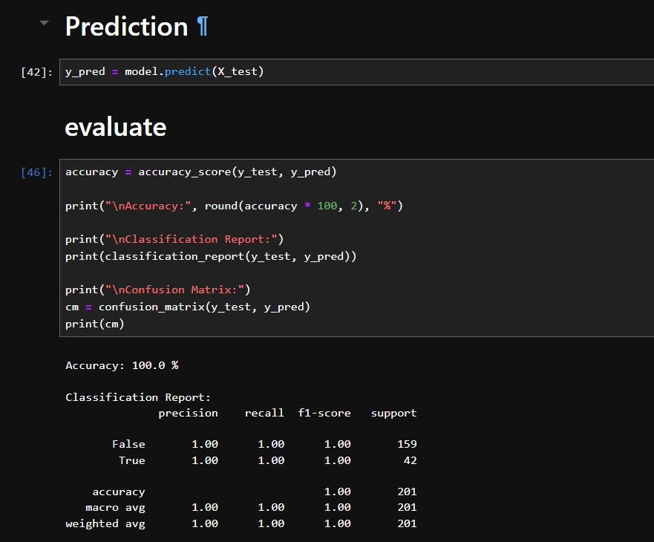
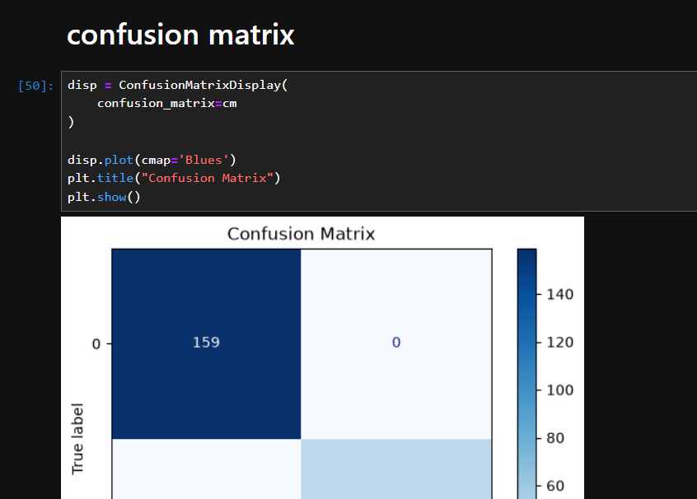
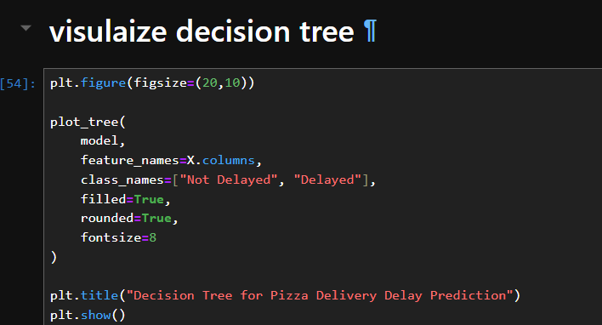
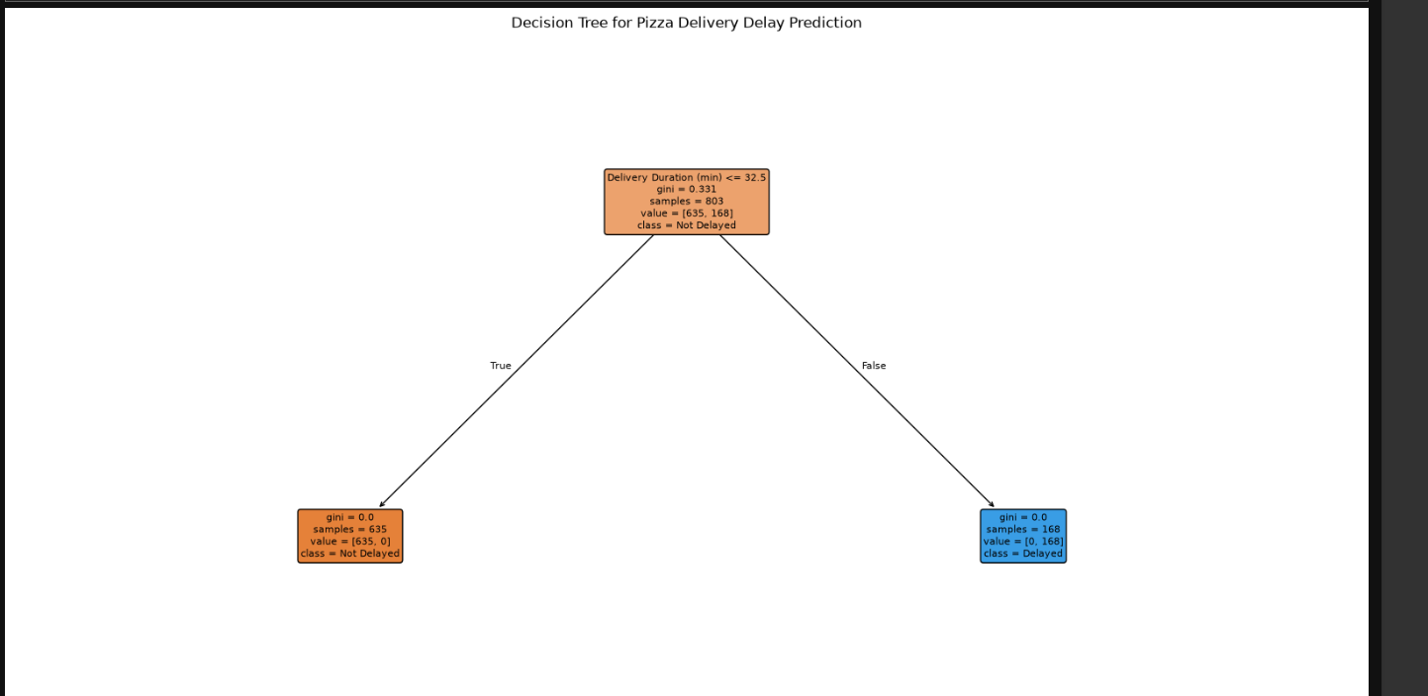

Lab 11: Naïve Bayes
Dataset Description
The Balanced Bank Marketing Dataset contains customer information collected from a bank's marketing campaigns. The dataset is used to predict whether a customer will subscribe to a term deposit (y: Yes/No) based on demographic, financial, and campaign-related attributes such as age, job, marital status, education, balance, contact type, and previous campaign outcomes. Since the dataset is balanced, both classes (Yes and No) have nearly equal numbers of records, making it suitable for training and evaluating machine learning classification models without class imbalance issues.
Objectives of Using This Dataset
- To analyze customer characteristics and marketing campaign data.
- To predict whether a customer will subscribe to a term deposit.
- To implement and compare classification algorithms such as Naive Bayes (NB) and K-Nearest Neighbors (KNN).
- To evaluate model performance using metrics like Accuracy, Precision, Recall, F1-score, and Confusion Matrix.
- To identify the most effective machine learning model for customer subscription prediction.
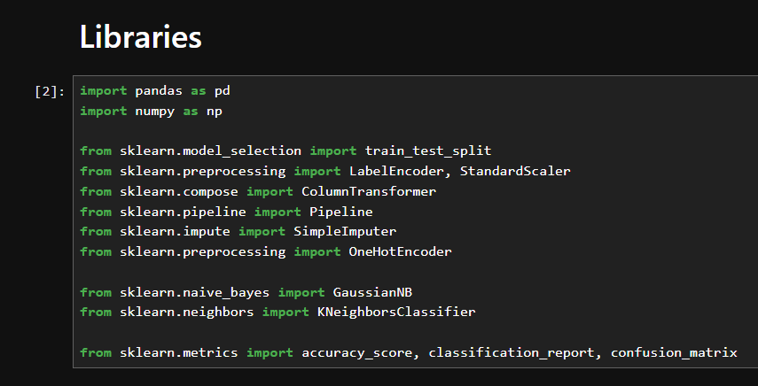
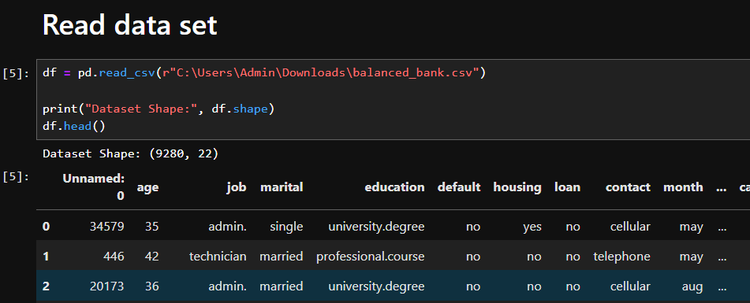
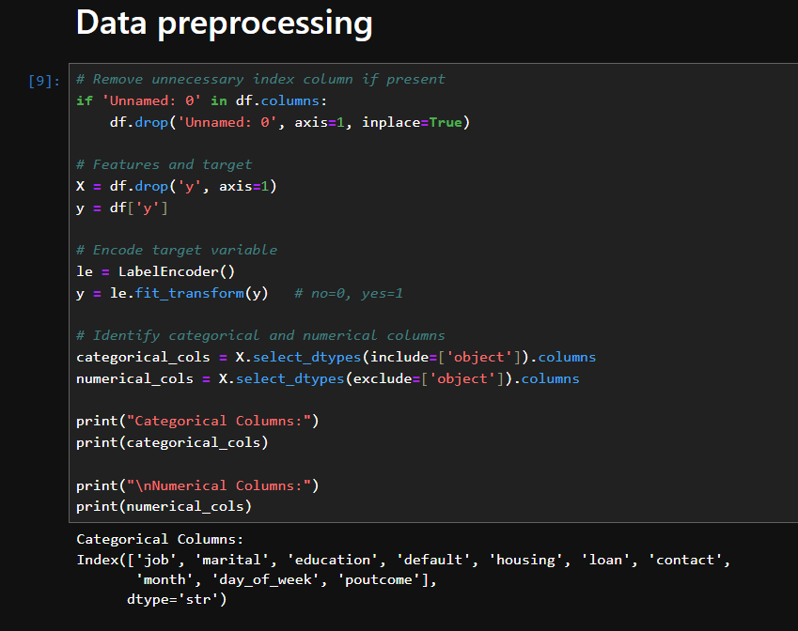
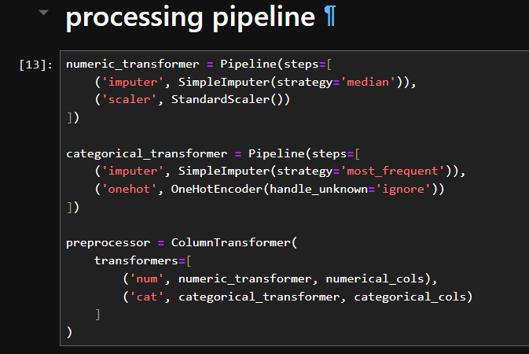
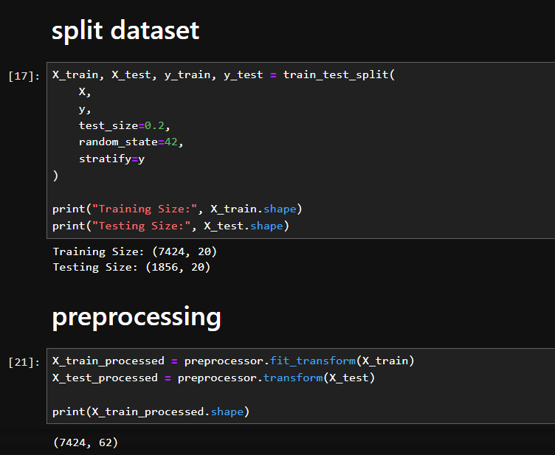
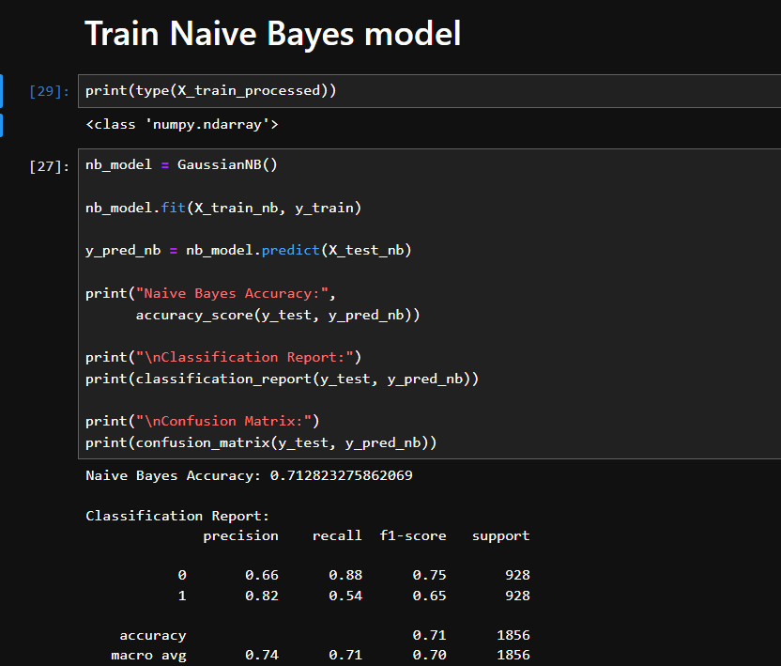
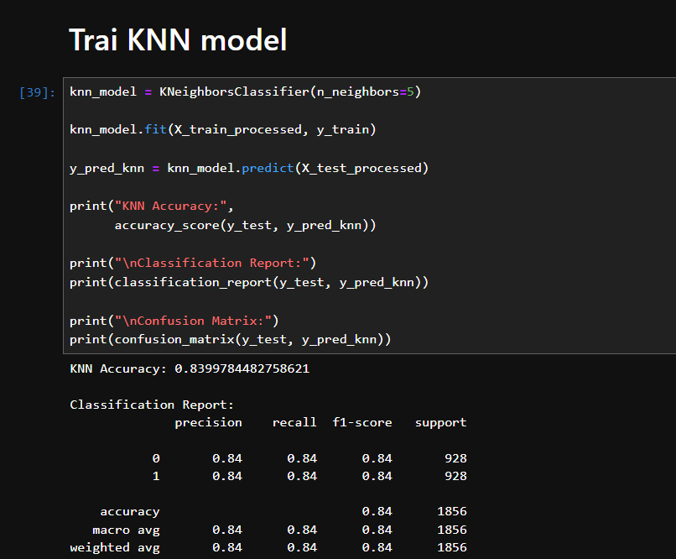
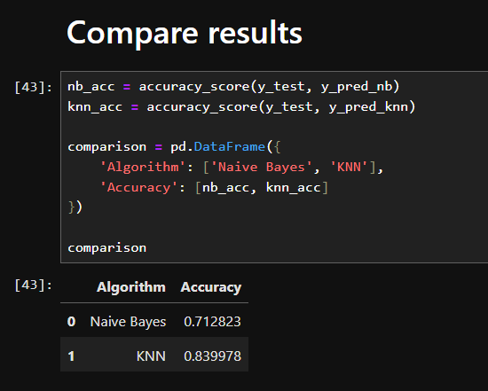
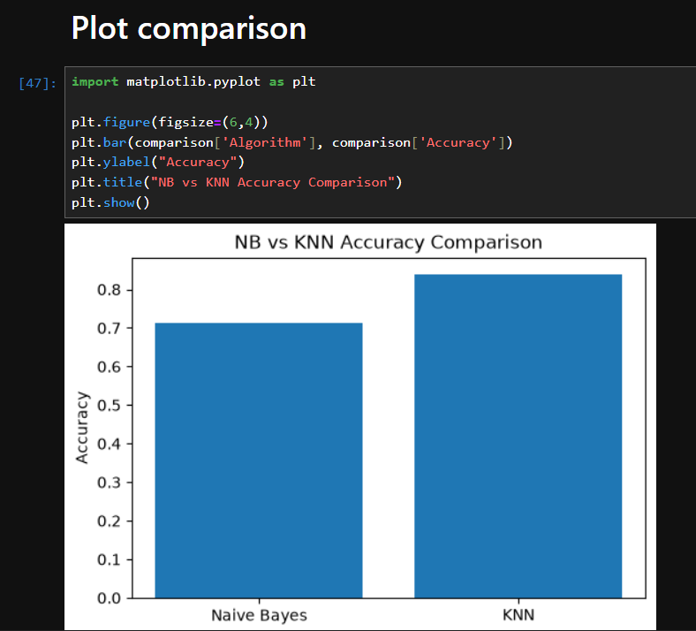

Lab 12: Naïve Bayes
Dataset Description
The Pizza Sales and Delivery Dataset contains information about pizza orders, restaurants, delivery conditions, and customer transactions. It includes features such as restaurant name, pizza type, size, delivery distance, traffic level, payment method, delivery duration, and delay status. The dataset is useful for analyzing delivery performance and customer service efficiency in the food delivery industry.
Objective
- Train Support Vector Machine (SVM) models using Linear and RBF kernels.
- Evaluate the models using Accuracy, Precision, Recall, F1-score, and Confusion Matrix.
- Compare both kernels to determine which performs better for predicting customer subscription outcomes in the bank marketing dataset.
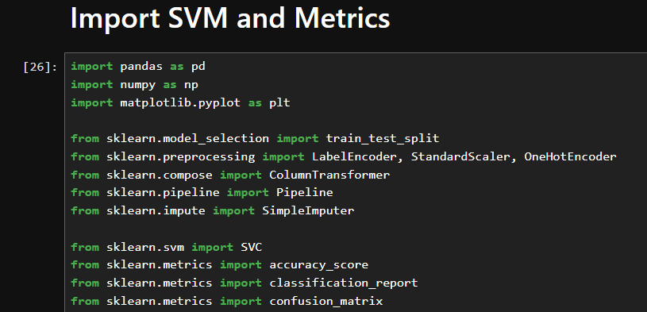
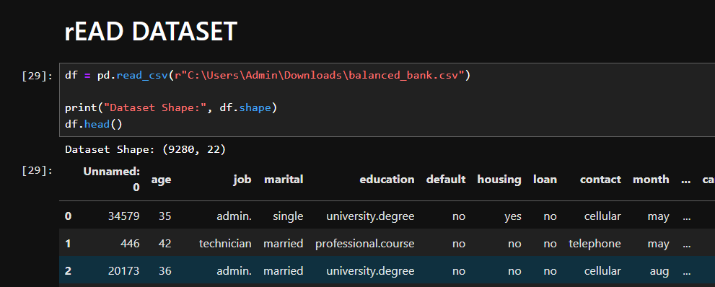
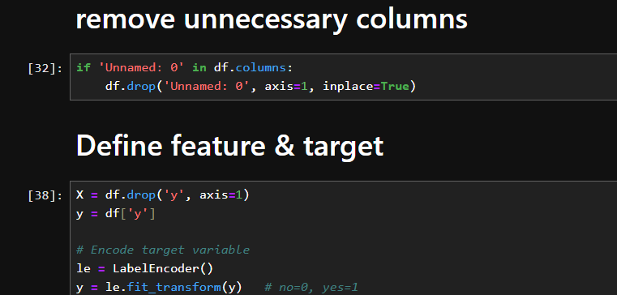
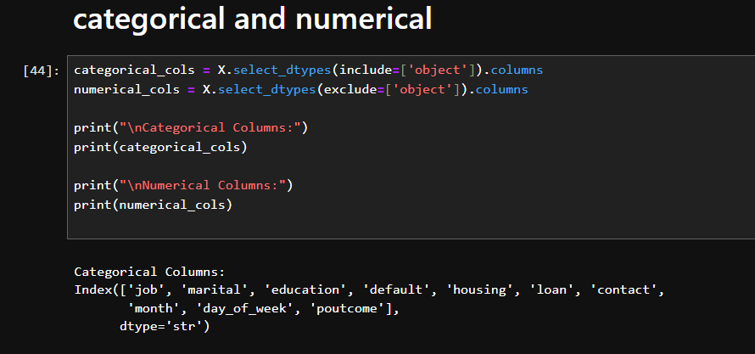
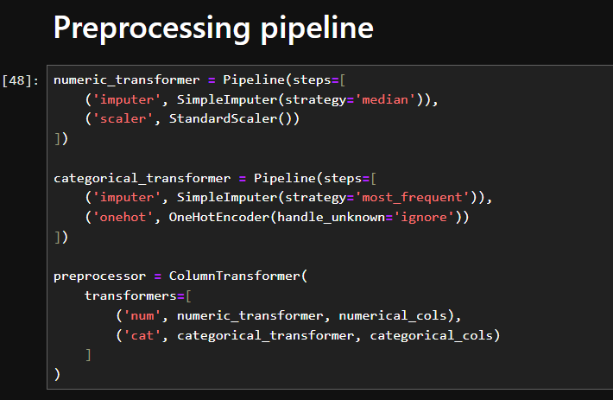
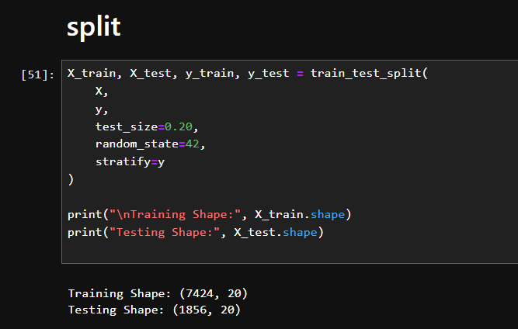
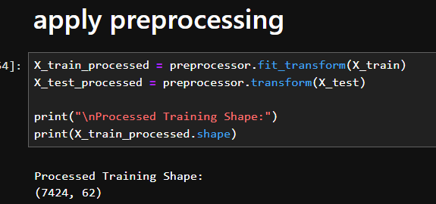
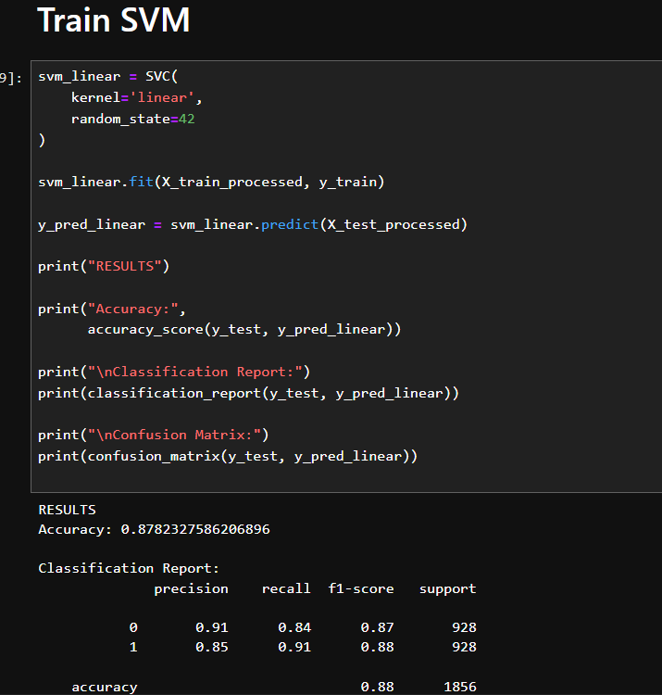
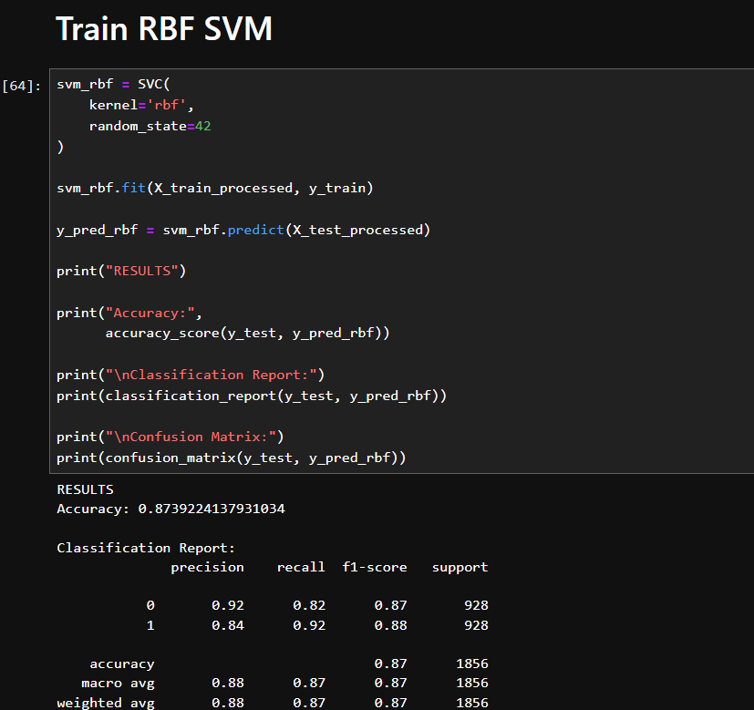
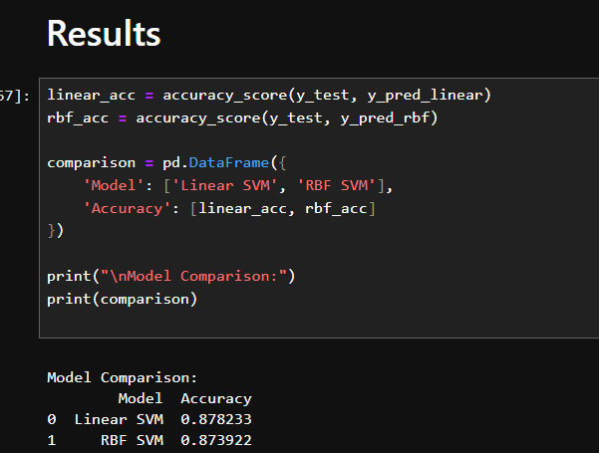
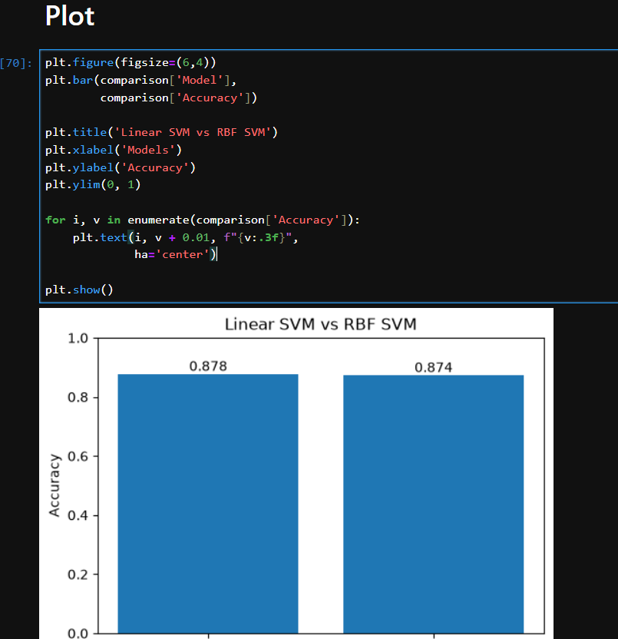

Lab 13: Clustering
Dataset Description
The Wholesale Customer Dataset contains annual spending data of customers from a wholesale distributor. Each record represents a customer and includes expenditures across different product categories such as Fresh products, Milk, Grocery items, Frozen foods, Detergents/Paper, and Delicatessen products. The dataset also contains customer information such as Channel (Hotel/Restaurant/Café or Retail) and Region.
This dataset is commonly used for customer segmentation and unsupervised learning techniques to identify groups of customers with similar purchasing behaviors.
Objectives of the Analysis
The main objectives of applying K-Means and Hierarchical Clustering to this dataset are:
- Identify Customer Segments
  - Group customers with similar spending patterns into distinct clusters.
- Understand Purchasing Behavior
  - Analyze how different customer groups spend across product categories.
- Compare Clustering Techniques
  - Evaluate and compare the results of K-Means and Hierarchical Clustering.
- Visualize Customer Groups
  - Use PCA-based visualizations and dendrograms to explore cluster structures.
- Support Business Decision-Making
  - Help wholesalers develop targeted marketing strategies, improve customer relationship management, and optimize product offerings for different customer segments.
Features in the Dataset
Feature | Description
Buyer/Spender | Customer ID
Channel | Customer type (Retail or Horeca)
Region | Geographic region
Fresh | Annual spending on fresh products
Milk | Annual spending on milk products
Grocery | Annual spending on grocery products
Frozen | Annual spending on frozen products
Detergents_Paper | Annual spending on detergents and paper products
Delicassen | Annual spending on delicatessen products

Analysis Type: Unsupervised Machine Learning (Customer Segmentation)
Algorithms Used: K-Means Clustering and Hierarchical Clustering
Visualization Methods: Elbow Method, Dendrogram, and PCA Scatter Plots.
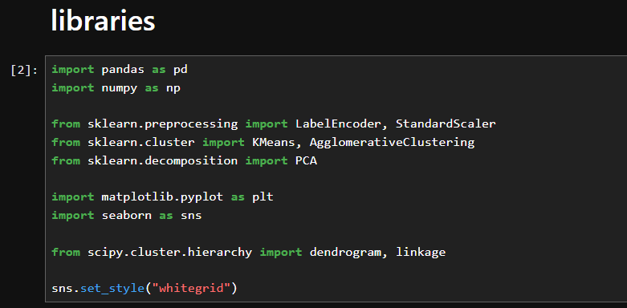
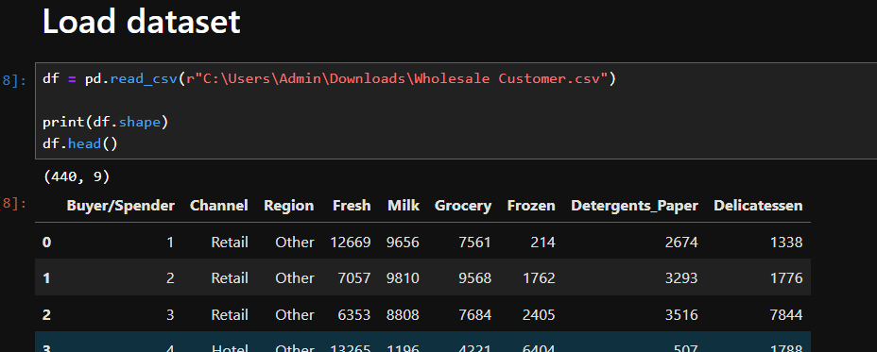
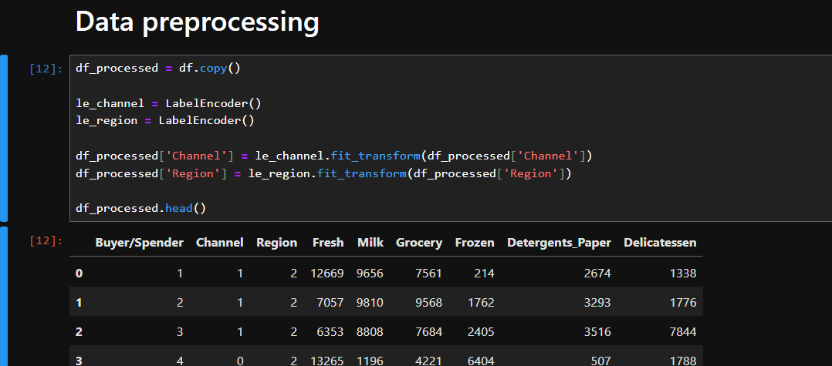
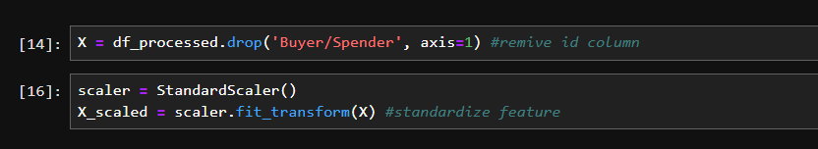
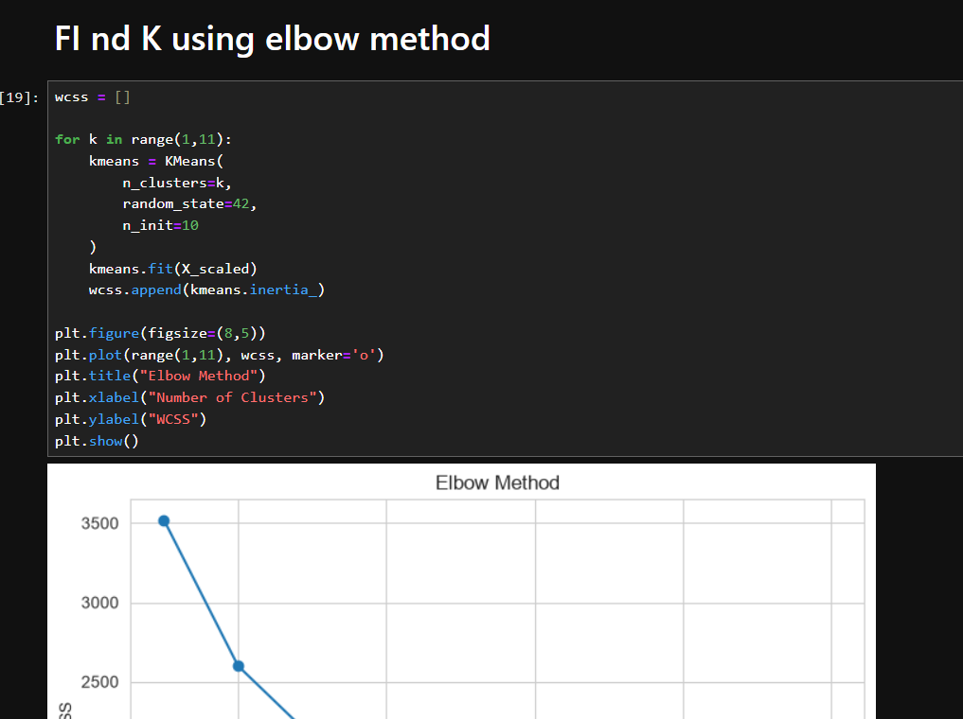
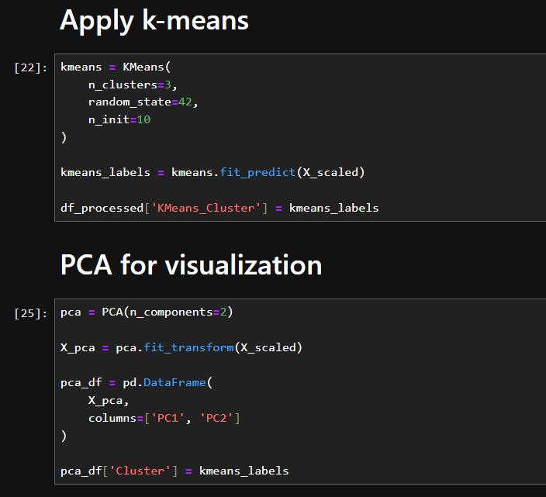

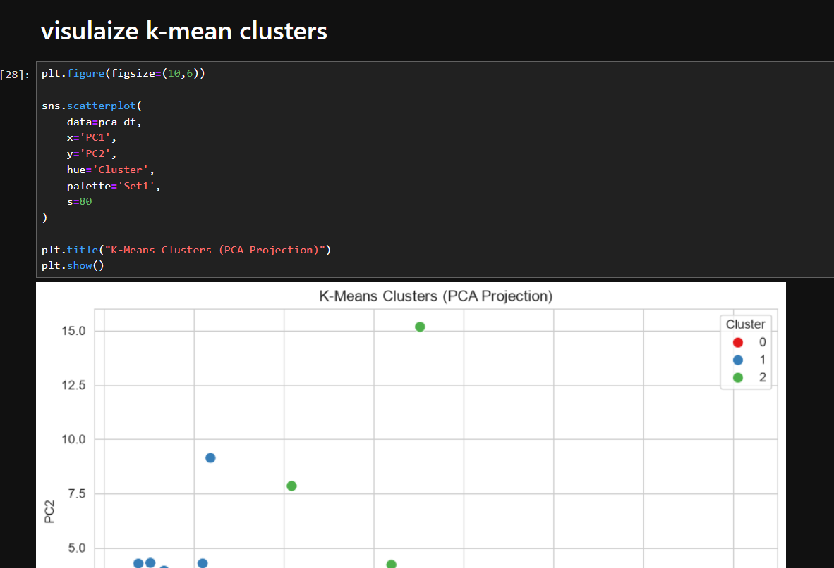
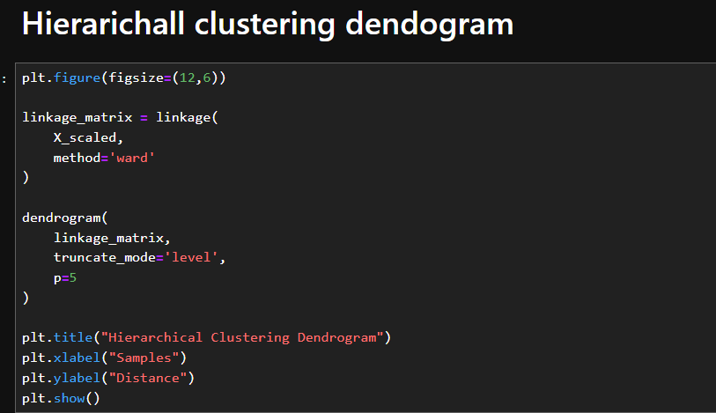
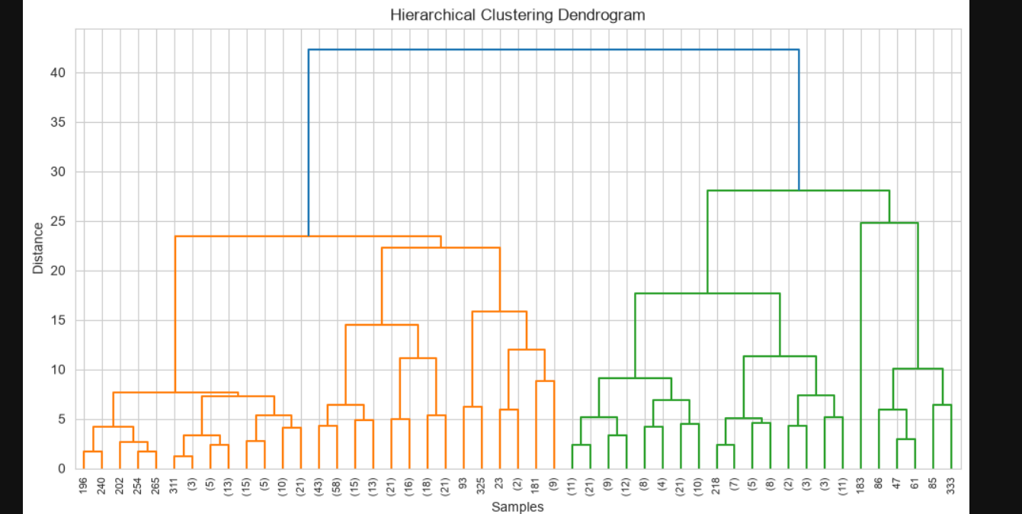
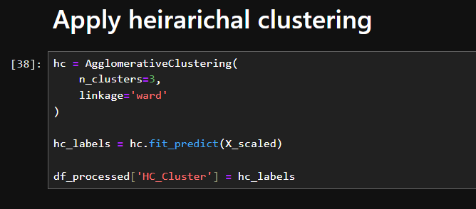
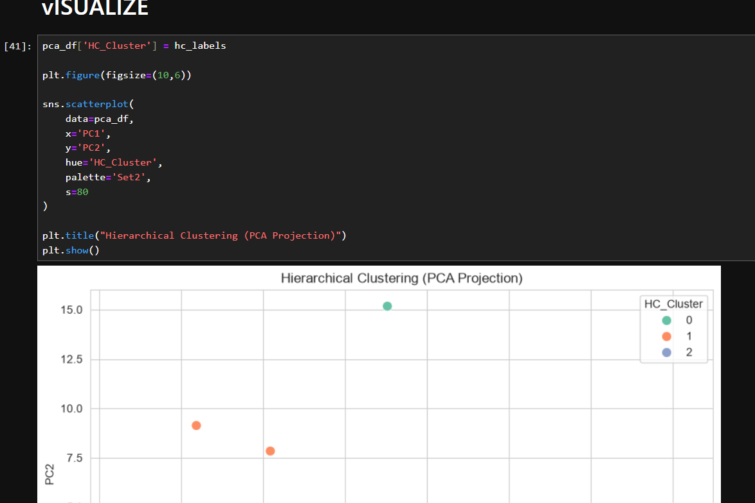
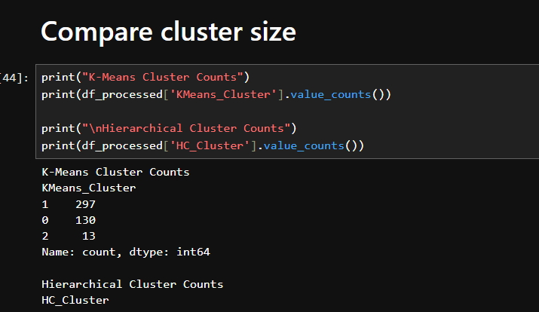
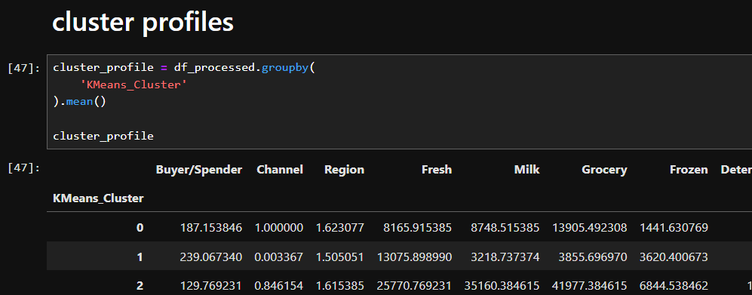

Lab 14: Outlier Detection
Dataset Description
The 2017 Yellow Taxi Trip Data dataset contains records of taxi trips in New York City. Each trip includes information such as pickup and dropoff locations, trip distance, fare amount, passenger count, trip duration, payment type, and other transportation-related attributes.
This dataset is commonly used for:
- Transportation analytics
- Traffic pattern analysis
- Fare analysis
- Anomaly (outlier) detection
- Demand forecasting
Objectives for Distance-Based & Isolation Forest
The purpose of applying anomaly detection techniques is to identify unusual taxi trips that differ significantly from normal trip patterns.
1. Distance-Based Outlier Detection
Identify trips that are far from other trips in the feature space based on:
- Trip distance
- Fare amount
- Passenger count
- Trip duration
- Total amount
Such trips may represent:
- Data entry errors
- Extremely long or short trips
- Unusual fare amounts
2. Isolation Forest
Use machine learning to isolate rare observations that have characteristics different from the majority of trips.
Potential anomalies include:
- Abnormally high fares
- Very long durations
- Unusually short trips with high charges
- Suspicious trip records
3. Visualization
Use PCA to project high-dimensional trip data into 2D and visualize:
- Normal trips
- Anomalous trips
4. Business Applications
- Fraud detection
- Data quality assessment
- Operational monitoring
- Identification of unusual travel patterns
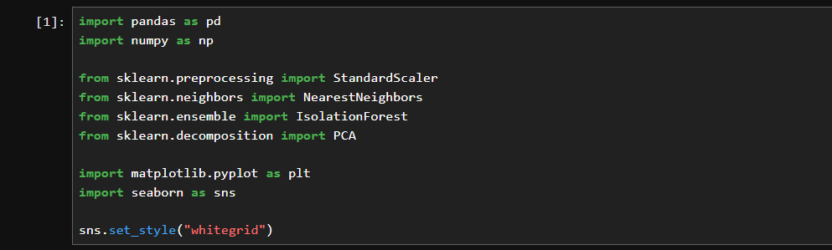
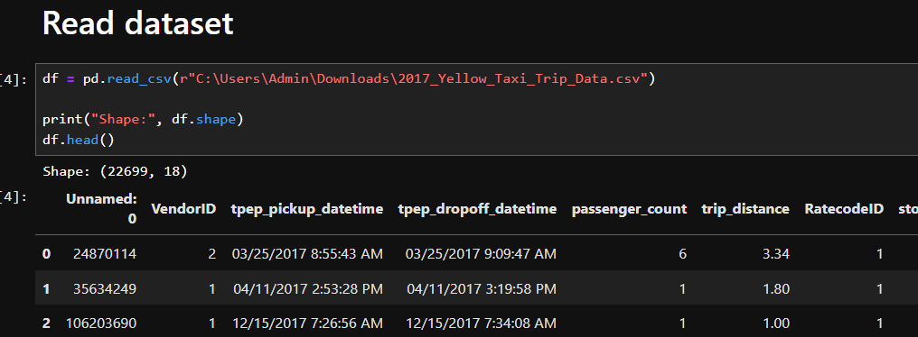
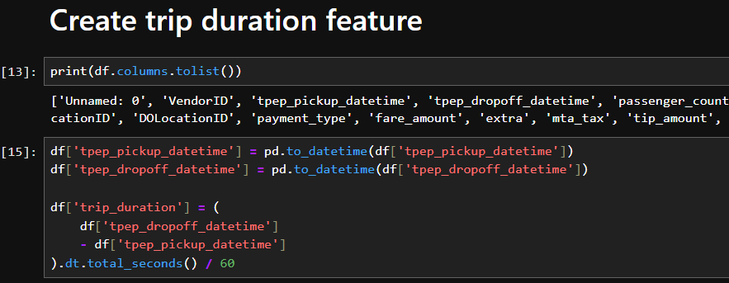
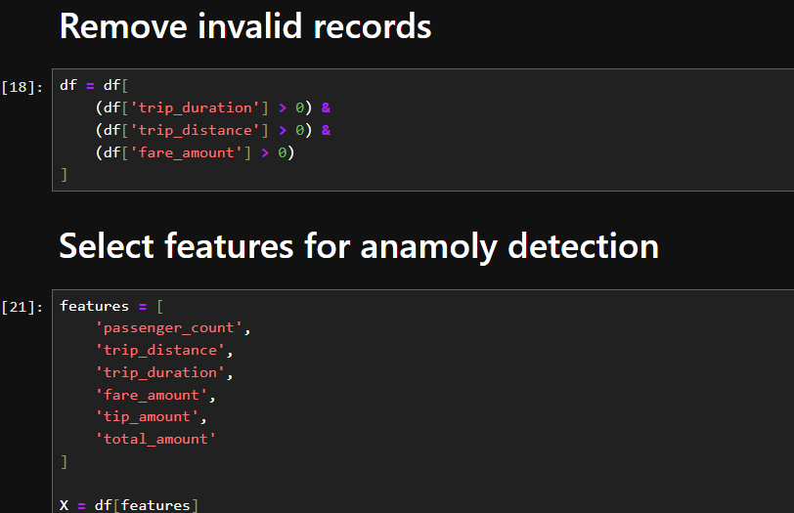
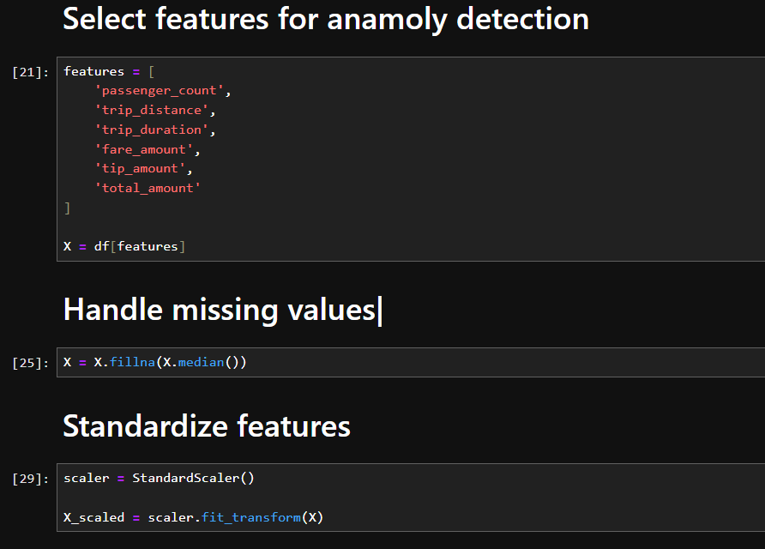

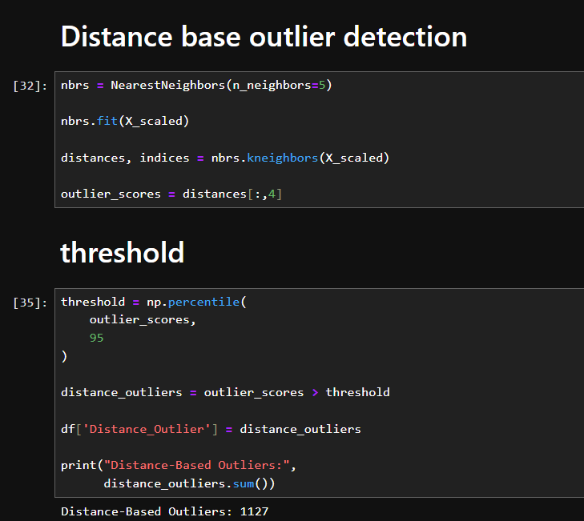
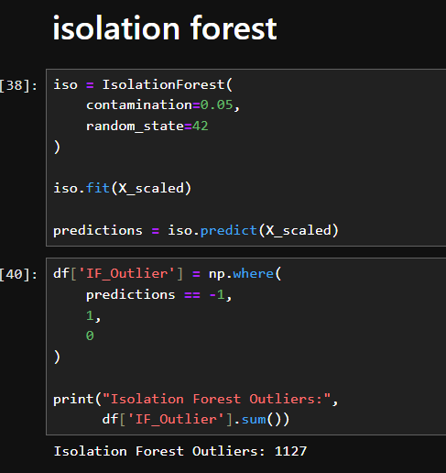
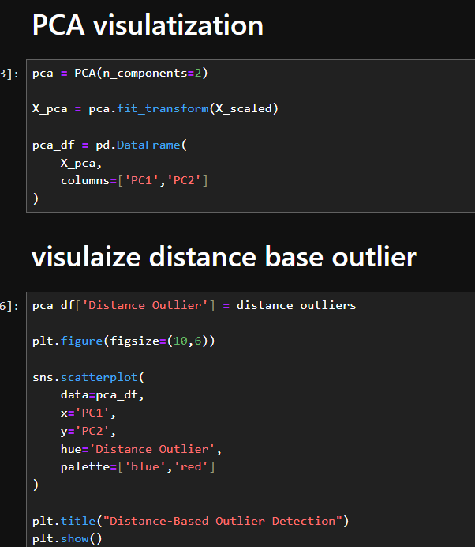

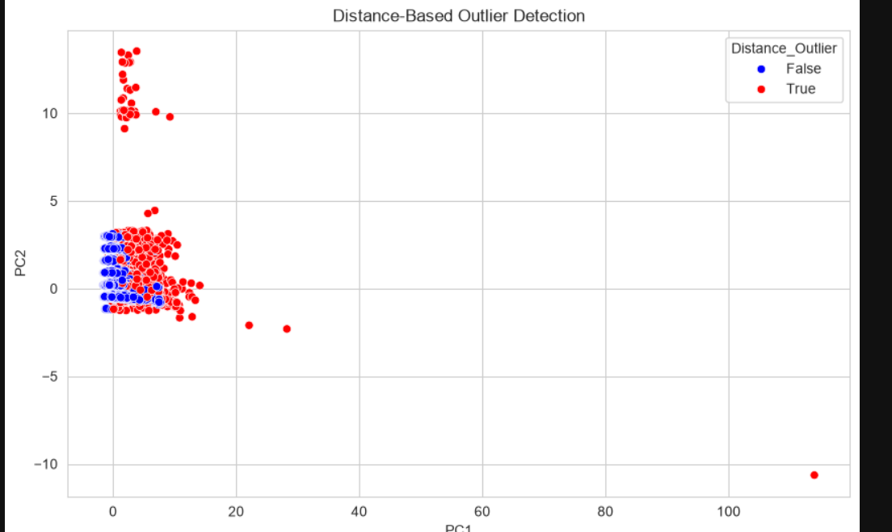
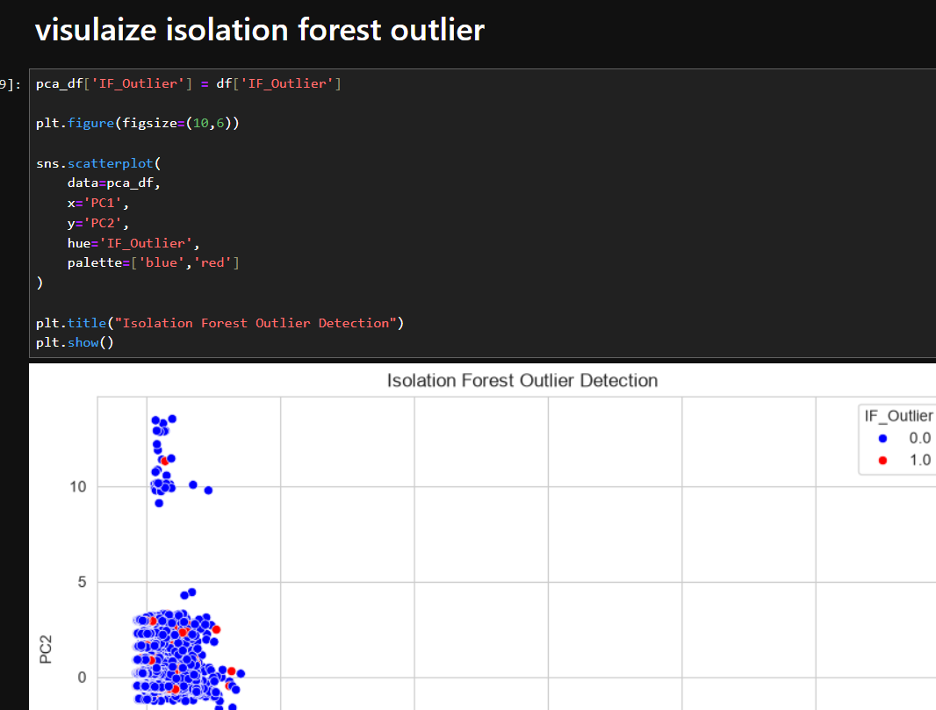
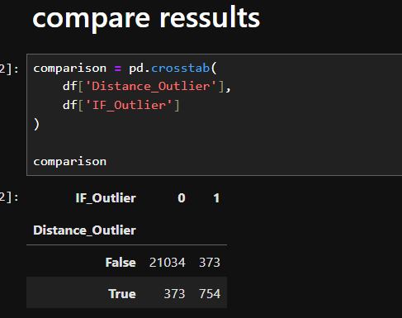
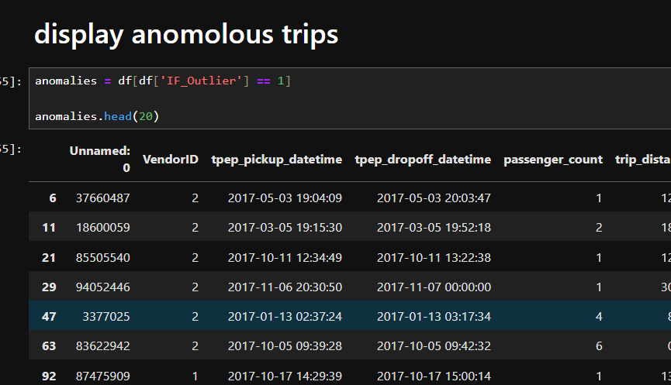
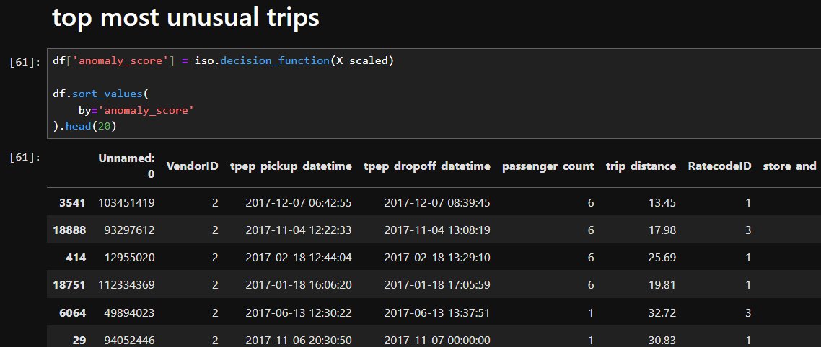

Lab 15: Scraping & Sentiment Analysis
Dataset Description
The IMDb Movie Review Dataset (labeledTrainData.tsv) contains 50,000 movie reviews collected from IMDb. Each review is labeled with a sentiment value indicating whether the review expresses a positive (1) or negative (0) opinion. The dataset is widely used for Natural Language Processing (NLP) and Sentiment Analysis tasks to train and evaluate machine learning models.
Features:
- id: Unique identifier for each review.
- sentiment: Target variable (0 = Negative, 1 = Positive).
- review: Text of the movie review.
Objectives
The main objectives are:
- Data Preprocessing: Clean and prepare textual data by removing HTML tags, punctuation, stop words, and unnecessary characters.
- Text Feature Extraction: Convert text reviews into numerical representations using techniques such as TF-IDF.
- Sentiment Classification: Build a machine learning model to classify reviews as positive or negative.
- Model Evaluation: Measure the performance of the classifier using metrics such as accuracy, precision, recall, and F1-score.
- Sentiment Prediction: Use the trained model to predict the sentiment of new, unseen movie reviews.
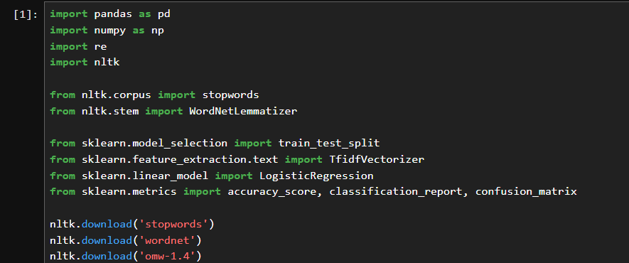
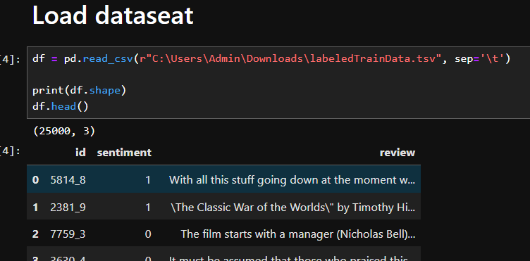
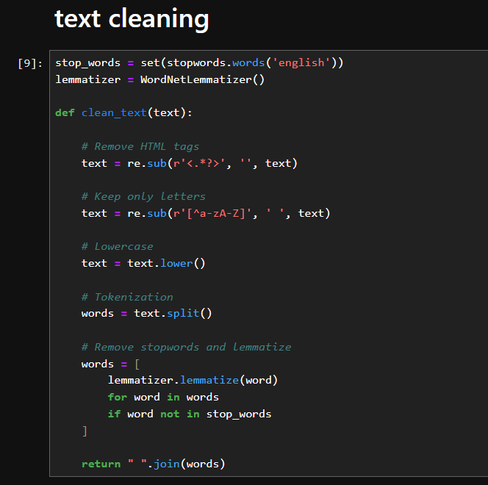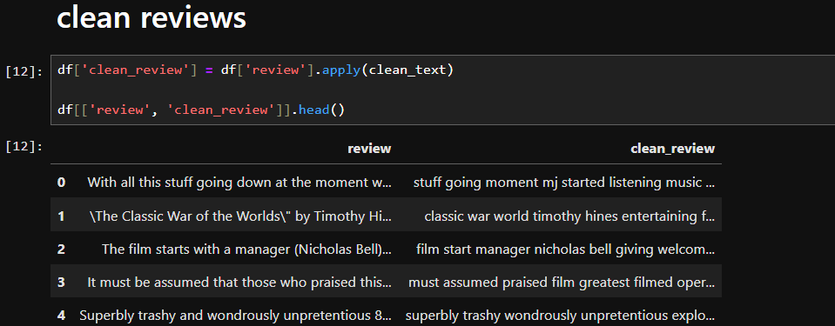
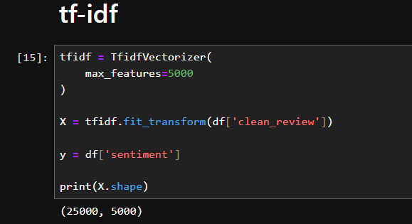
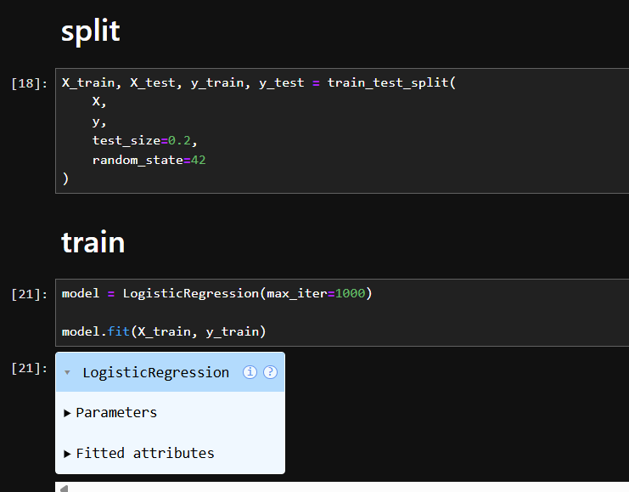
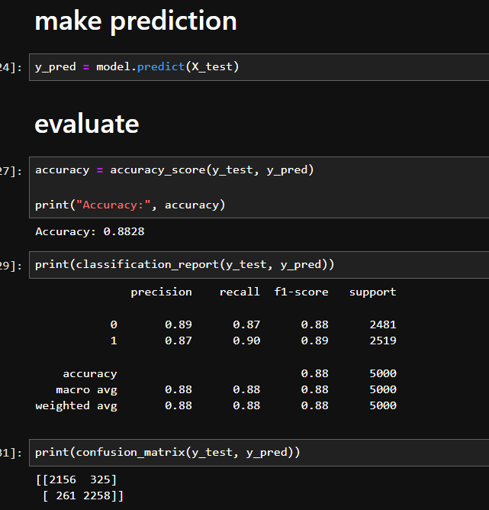
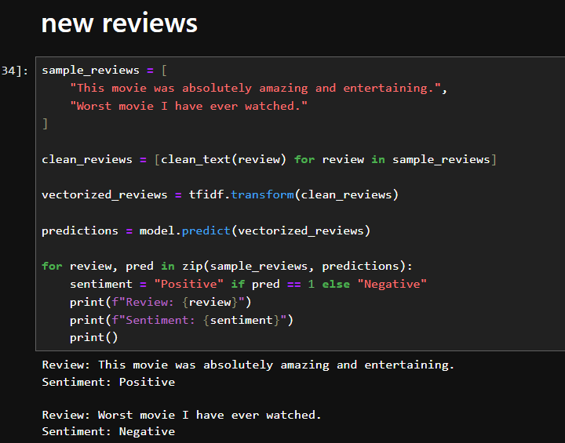
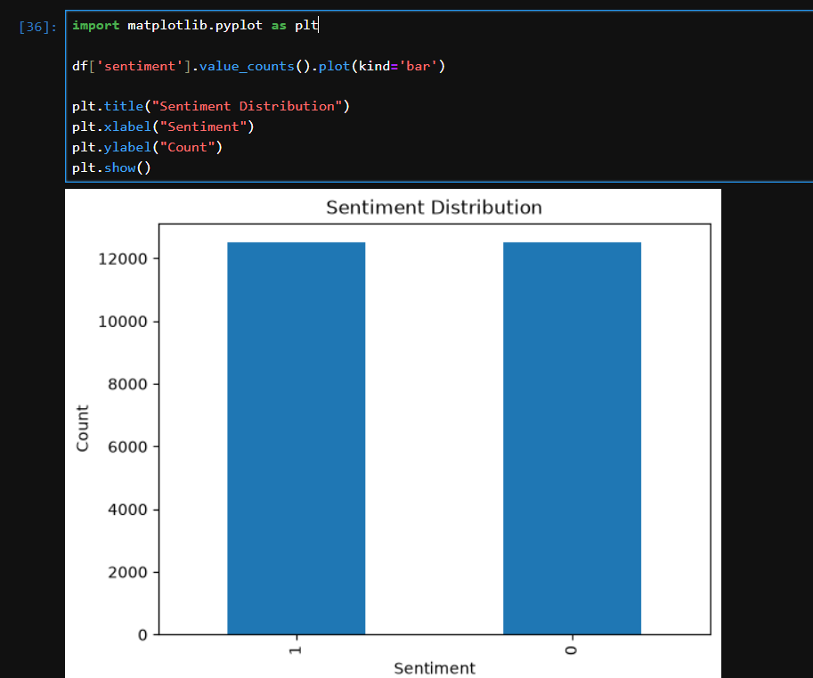

Lab 16: Final Capstone
Dataset Description
The World Education Data Dataset contains educational indicators from multiple countries around the world. It includes information related to literacy rates, school enrollment, government expenditure on education, pupil-teacher ratios, and other education-related metrics. The dataset is useful for analyzing global education trends and understanding the factors that influence educational outcomes across different regions.
Key Features
Some important variables in the dataset include:
- Country – Name of the country.
- Adult Literacy Rate (%) – Percentage of adults who can read and write.
- Primary School Enrollment (%) – Enrollment rate in primary education.
- Secondary School Enrollment (%) – Enrollment rate in secondary education.
- Government Education Expenditure (%) – Government spending on education.
- Pupil-Teacher Ratio – Number of students per teacher.
- Youth Literacy Rate (%) – Literacy rate among young people.
- Additional demographic and educational indicators.
Project Objectives
- Explore and understand the educational characteristics of countries worldwide.
- Clean and preprocess the dataset by handling missing values, duplicates, and categorical variables.
- Analyze relationships between educational indicators and literacy rates.
- Build predictive models to estimate educational outcomes (e.g., adult literacy rate).
- Compare the performance of multiple machine learning algorithms using evaluation metrics such as R² Score, MAE, and RMSE.
- Identify the most influential factors affecting educational performance.
- Interpret model results to derive meaningful insights that can support educational planning and policy-making.

